## Best practices of Engineering

Design Patterns

Design patterns represent the best practices used by experienced object-oriented software developers. Design patterns are solutions to general problems that software developers faced during software development. These solutions were obtained by trial and error by numerous software developers over quite a substantial period of time.

## Usage of Design Pattern

Design Patterns have two main usages in software development.

### Common platform for developers

Design patterns provide a standard terminology and are specific to particular scenario. For example, a singleton design pattern signifies use of single object so all developers familiar with single design pattern will make use of single object and they can tell each other that program is following a singleton pattern.

### Best Practices

Design patterns have been evolved over a long period of time and they provide best solutions to certain problems faced during software development. Learning these patterns helps unexperienced developers to learn software design in an easy and faster way.

## Types of Design Patterns

As per the design pattern reference book **Design Patterns - Elements of Reusable Object-Oriented Software** , there are 23 design patterns which can be classified in three categories: Creational, Structural and Behavioral patterns.

|  |  |
| --- | --- |
| **S.N.** | **Pattern & Description** |
| 1 | **Creational Patterns** These design patterns provide a way to create objects while hiding the creation logic, rather than instantiating objects directly using new operator. This gives program more flexibility in deciding which objects need to be created for a given use case. |
| 2 | **Structural Patterns** These design patterns concern class and object composition. Concept of inheritance is used to compose interfaces and define ways to compose objects to obtain new functionalities. |
| 3 | **Behavioral Patterns** These design patterns are specifically concerned with communication between objects. |

Creational DP Types are Abstract Factory, Factory Method, builder,object pool, prototype,singleton

# Factory Method

**Also known as:**Virtual Constructor

**https://refactoring.guru/design-patterns/factory-method**

## Intent

**Factory Method** is a creational design pattern that provides an interface for creating objects in a superclass, but allows subclasses to alter the type of objects that will be created.

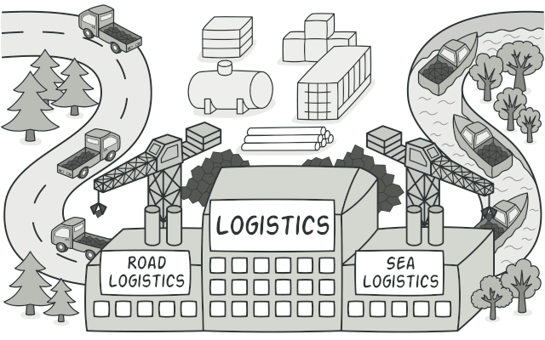

## Problem

Imagine that you’re creating a logistics management application. The first version of your app can only handle transportation by trucks, so the bulk of your code lives inside the Truck class.

After a while, your app becomes pretty popular. Each day you receive dozens of requests from sea transportation companies to incorporate sea logistics into the app.

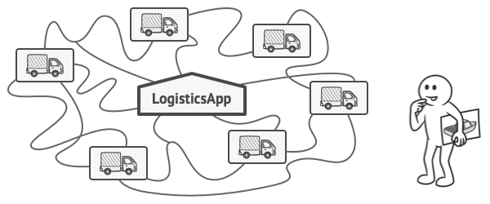

Adding a new class to the program isn’t that simple if the rest of the code is already coupled to existing classes.

Great news, right? But how about the code? At present, most of your code is coupled to the Truck class. Adding Ships into the app would require making changes to the entire codebase. Moreover, if later you decide to add another type of transportation to the app, you will probably need to make all of these changes again.

As a result, you will end up with pretty nasty code, riddled with conditionals that switch the app’s behavior depending on the class of transportation objects.

## Solution

The Factory Method pattern suggests that you replace direct object construction calls (using the new operator) with calls to a special factory method. Don’t worry: the objects are still created via the new operator, but it’s being called from within the factory method. Objects returned by a factory method are often referred to as products.

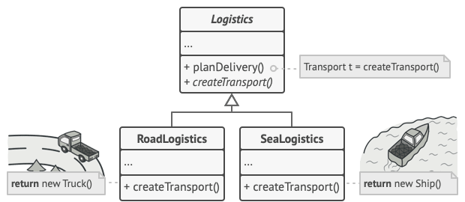

Subclasses can alter the class of objects being returned by the factory method.

At first glance, this change may look pointless: we just moved the constructor call from one part of the program to another. However, consider this: now you can override the factory method in a subclass and change the class of products being created by the method.

There’s a slight limitation though: subclasses may return different types of products only if these products have a common base class or interface. Also, the factory method in the base class should have its return type declared as this interface.

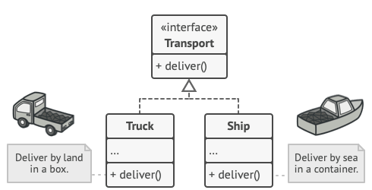

All products must follow the same interface.

For example, both Truck and Ship classes should implement the Transport interface, which declares a method called deliver. Each class implements this method differently: trucks deliver cargo by land, ships deliver cargo by sea. The factory method in the RoadLogistics class returns truck objects, whereas the factory method in the SeaLogistics class returns ships.

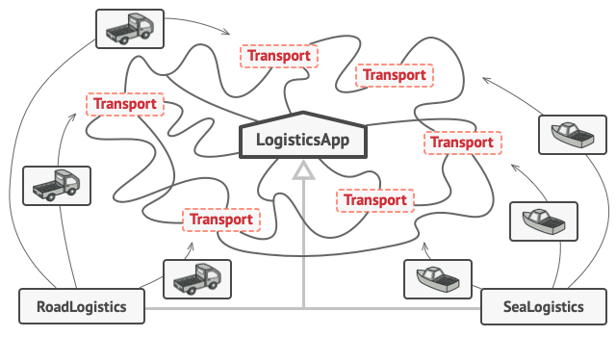

As long as all product classes implement a common interface, you can pass their objects to the client code without breaking it.

The code that uses the factory method (often called the client code) doesn’t see a difference between the actual products returned by various subclasses. The client treats all the products as abstract Transport. The client knows that all transport objects are supposed to have the deliver method, but exactly how it works isn’t important to the client.

<https://refactoring.guru/design-patterns/factory-method>

# Abstract Factory

## Intent

**Abstract Factory** is a creational design pattern that lets you produce families of related objects without specifying their concrete classes.

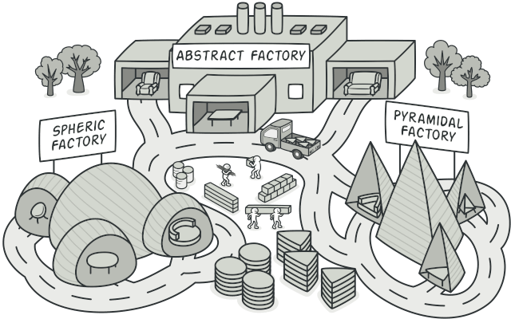

## Problem

Imagine that you’re creating a furniture shop simulator. Your code consists of classes that represent:

1. A family of related products, say: Chair + Sofa + CoffeeTable.
2. Several variants of this family. For example, products Chair + Sofa + CoffeeTable are available in these variants: Modern, Victorian, ArtDeco.

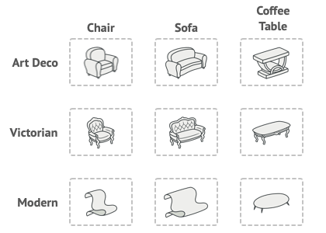

Product families and their variants.

You need a way to create individual furniture objects so that they match other objects of the same family. Customers get quite mad when they receive non-matching furniture.

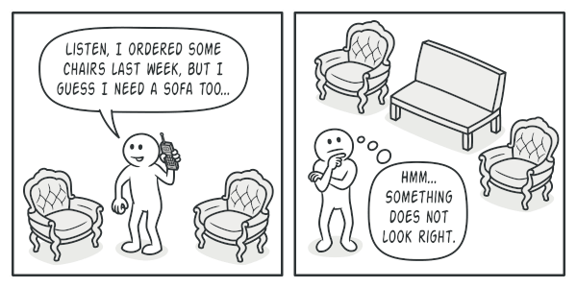

A Modern-style sofa doesn’t match Victorian-style chairs.

Also, you don’t want to change existing code when adding new products or families of products to the program. Furniture vendors update their catalogs very often, and you wouldn’t want to change the core code each time it happens.

## Solution

The first thing the Abstract Factory pattern suggests is to explicitly declare interfaces for each distinct product of the product family (e.g., chair, sofa or coffee table). Then you can make all variants of products follow those interfaces. For example, all chair variants can implement the Chair interface; all coffee table variants can implement the CoffeeTable interface, and so on.

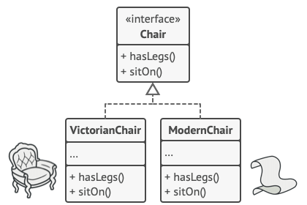

All variants of the same object must be moved to a single class hierarchy.

The next move is to declare the Abstract Factory—an interface with a list of creation methods for all products that are part of the product family (for example, createChair, createSofa and createCoffeeTable). These methods must return **abstract** product types represented by the interfaces we extracted previously: Chair, Sofa, CoffeeTable and so on.

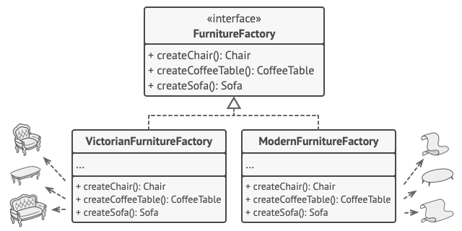

Each concrete factory corresponds to a specific product variant.

Now, how about the product variants? For each variant of a product family, we create a separate factory class based on the AbstractFactory interface. A factory is a class that returns products of a particular kind. For example, the ModernFurnitureFactory can only create ModernChair, ModernSofa and ModernCoffeeTable objects.

The client code has to work with both factories and products via their respective abstract interfaces. This lets you change the type of a factory that you pass to the client code, as well as the product variant that the client code receives, without breaking the actual client code.



The client shouldn’t care about the concrete class of the factory it works with.

Say the client wants a factory to produce a chair. The client doesn’t have to be aware of the factory’s class, nor does it matter what kind of chair it gets. Whether it’s a Modern model or a Victorian-style chair, the client must treat all chairs in the same manner, using the abstract Chair interface. With this approach, the only thing that the client knows about the chair is that it implements the sitOn method in some way. Also, whichever variant of the chair is returned, it’ll always match the type of sofa or coffee table produced by the same factory object.

There’s one more thing left to clarify: if the client is only exposed to the abstract interfaces, what creates the actual factory objects? Usually, the application creates a concrete factory object at the initialization stage. Just before that, the app must select the factory type depending on the configuration or the environment settings.

# Builder

## Intent

**Builder** is a creational design pattern that lets you construct complex objects step by step. The pattern allows you to produce different types and representations of an object using the same construction code.

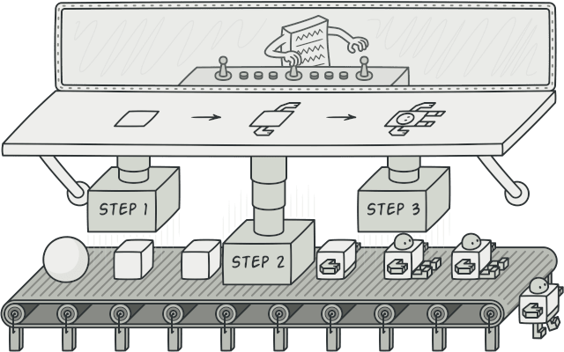

## Problem

Imagine a complex object that requires laborious, step-by-step initialization of many fields and nested objects. Such initialization code is usually buried inside a monstrous constructor with lots of parameters. Or even worse: scattered all over the client code.

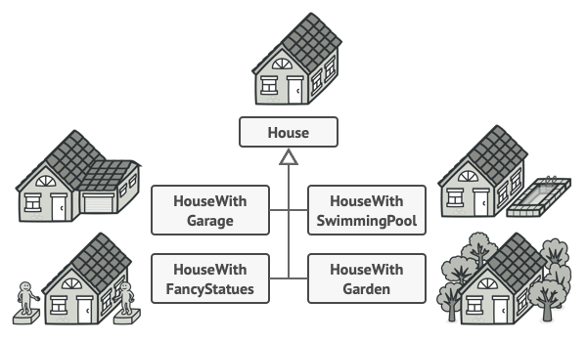

You might make the program too complex by creating a subclass for every possible configuration of an object.

For example, let’s think about how to create a House object. To build a simple house, you need to construct four walls and a floor, install a door, fit a pair of windows, and build a roof. But what if you want a bigger, brighter house, with a backyard and other goodies (like a heating system, plumbing, and electrical wiring)?

The simplest solution is to extend the base House class and create a set of subclasses to cover all combinations of the parameters. But eventually you’ll end up with a considerable number of subclasses. Any new parameter, such as the porch style, will require growing this hierarchy even more.

There’s another approach that doesn’t involve breeding subclasses. You can create a giant constructor right in the base House class with all possible parameters that control the house object. While this approach indeed eliminates the need for subclasses, it creates another problem.

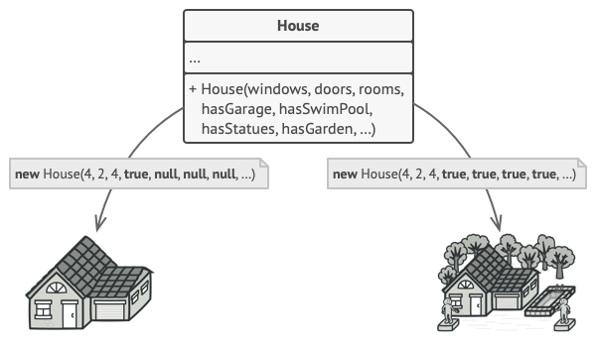

The constructor with lots of parameters has its downside: not all the parameters are needed at all times.

In most cases most of the parameters will be unused, making [**the constructor calls pretty ugly**](https://refactoring.guru/smells/long-parameter-list). For instance, only a fraction of houses have swimming pools, so the parameters related to swimming pools will be useless nine times out of ten.

## Solution

The Builder pattern suggests that you extract the object construction code out of its own class and move it to separate objects called builders.

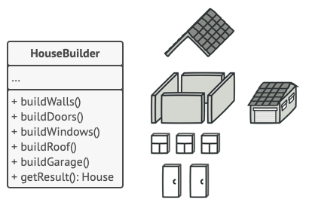

The Builder pattern lets you construct complex objects step by step. The Builder doesn’t allow other objects to access the product while it’s being built.

The pattern organizes object construction into a set of steps (buildWalls, buildDoor, etc.). To create an object, you execute a series of these steps on a builder object. The important part is that you don’t need to call all of the steps. You can call only those steps that are necessary for producing a particular configuration of an object.

Some of the construction steps might require different implementation when you need to build various representations of the product. For example, walls of a cabin may be built of wood, but the castle walls must be built with stone.

In this case, you can create several different builder classes that implement the same set of building steps, but in a different manner. Then you can use these builders in the construction process (i.e., an ordered set of calls to the building steps) to produce different kinds of objects.

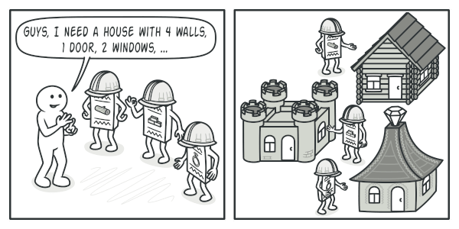

Different builders execute the same task in various ways.

For example, imagine a builder that builds everything from wood and glass, a second one that builds everything with stone and iron and a third one that uses gold and diamonds. By calling the same set of steps, you get a regular house from the first builder, a small castle from the second and a palace from the third. However, this would only work if the client code that calls the building steps is able to interact with builders using a common interface

# Prototype

**Also known as:**Clone

## Intent

**Prototype** is a creational design pattern that lets you copy existing objects without making your code dependent on their classes.

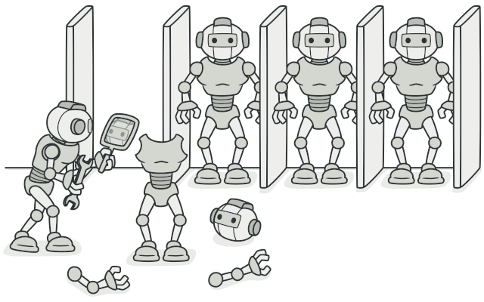

## Problem

Say you have an object, and you want to create an exact copy of it. How would you do it? First, you have to create a new object of the same class. Then you have to go through all the fields of the original object and copy their values over to the new object.

Nice! But there’s a catch. Not all objects can be copied that way because some of the object’s fields may be private and not visible from outside of the object itself.



Copying an object “from the outside” [**isn’t**](https://refactoring.guru/cargo-cult) always possible.

There’s one more problem with the direct approach. Since you have to know the object’s class to create a duplicate, your code becomes dependent on that class. If the extra dependency doesn’t scare you, there’s another catch. Sometimes you only know the interface that the object follows, but not its concrete class, when, for example, a parameter in a method accepts any objects that follow some interface.

## Solution

The Prototype pattern delegates the cloning process to the actual objects that are being cloned. The pattern declares a common interface for all objects that support cloning. This interface lets you clone an object without coupling your code to the class of that object. Usually, such an interface contains just a single clone method.

The implementation of the clone method is very similar in all classes. The method creates an object of the current class and carries over all of the field values of the old object into the new one. You can even copy private fields because most programming languages let objects access private fields of other objects that belong to the same class.

An object that supports cloning is called a prototype. When your objects have dozens of fields and hundreds of possible configurations, cloning them might serve as an alternative to subclassing.

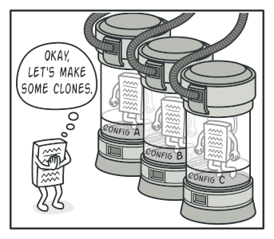

Pre-built prototypes can be an alternative to subclassing.

Here’s how it works: you create a set of objects, configured in various ways. When you need an object like the one you’ve configured, you just clone a prototype instead of constructing a new object from scratch.

## Real-World Analogy

In real life, prototypes are used for performing various tests before starting mass production of a product. However, in this case, prototypes don’t participate in any actual production, playing a passive role instead.

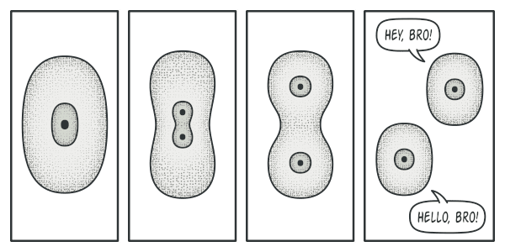

The division of a cell.

Since industrial prototypes don’t really copy themselves, a much closer analogy to the pattern is the process of mitotic cell division (biology, remember?). After mitotic division, a pair of identical cells is formed. The original cell acts as a prototype and takes an active role in creating the copy.

# ingleton

## Intent

**Singleton** is a creational design pattern that lets you ensure that a class has only one instance, while providing a global access point to this instance.

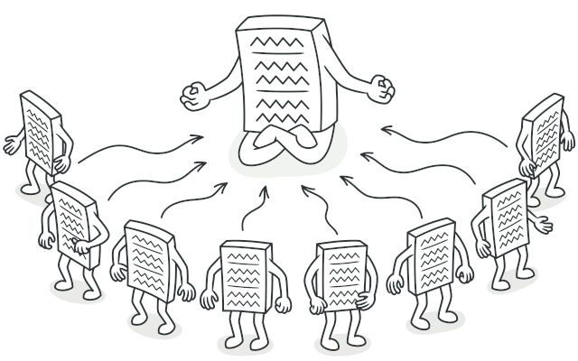

## Problem

The Singleton pattern solves two problems at the same time, violating the Single Responsibility Principle:

1. **Ensure that a class has just a single instance**. Why would anyone want to control how many instances a class has? The most common reason for this is to control access to some shared resource—for example, a database or a file.

Here’s how it works: imagine that you created an object, but after a while decided to create a new one. Instead of receiving a fresh object, you’ll get the one you already created.

Note that this behavior is impossible to implement with a regular constructor since a constructor call **must** always return a new object by design.

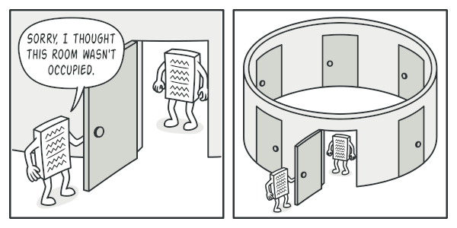

Clients may not even realize that they’re working with the same object all the time.

1. **Provide a global access point to that instance**. Remember those global variables that you (all right, me) used to store some essential objects? While they’re very handy, they’re also very unsafe since any code can potentially overwrite the contents of those variables and crash the app.

Just like a global variable, the Singleton pattern lets you access some object from anywhere in the program. However, it also protects that instance from being overwritten by other code.

There’s another side to this problem: you don’t want the code that solves problem #1 to be scattered all over your program. It’s much better to have it within one class, especially if the rest of your code already depends on it.

Nowadays, the Singleton pattern has become so popular that people may call something a singleton even if it solves just one of the listed problems.

## Solution

All implementations of the Singleton have these two steps in common:

* Make the default constructor private, to prevent other objects from using the new operator with the Singleton class.
* Create a static creation method that acts as a constructor. Under the hood, this method calls the private constructor to create an object and saves it in a static field. All following calls to this method return the cached object.

If your code has access to the Singleton class, then it’s able to call the Singleton’s static method. So whenever that method is called, the same object is always returned.

## Real-World Analogy

The government is an excellent example of the Singleton pattern. A country can have only one official government. Regardless of the personal identities of the individuals who form governments, the title, “The Government of X”, is a global point of access that identifies the group of people in charge.

Structural DP further has following types Adapter, Bridge, composite, decorator, Façade, Flyweight,private class data, proxy

# Adapter

**Also known as:**Wrapper

## Intent

**Adapter** is a structural design pattern that allows objects with incompatible interfaces to collaborate.

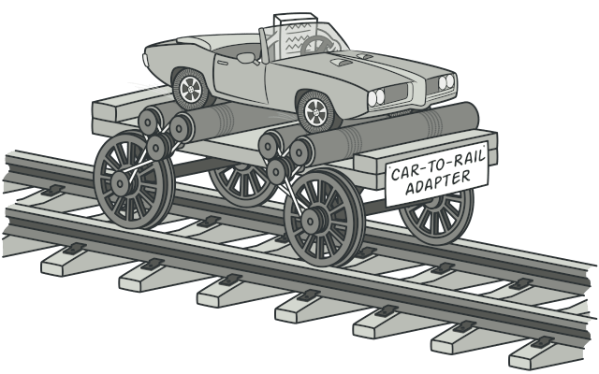

## Problem

Imagine that you’re creating a stock market monitoring app. The app downloads the stock data from multiple sources in XML format and then displays nice-looking charts and diagrams for the user.

At some point, you decide to improve the app by integrating a smart 3rd-party analytics library. But there’s a catch: the analytics library only works with data in JSON format.

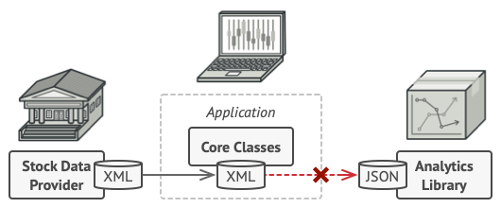

You can’t use the analytics library “as is” because it expects the data in a format that’s incompatible with your app.

You could change the library to work with XML. However, this might break some existing code that relies on the library. And worse, you might not have access to the library’s source code in the first place, making this approach impossible.

## Solution

You can create an adapter. This is a special object that converts the interface of one object so that another object can understand it.

An adapter wraps one of the objects to hide the complexity of conversion happening behind the scenes. The wrapped object isn’t even aware of the adapter. For example, you can wrap an object that operates in meters and kilometers with an adapter that converts all of the data to imperial units such as feet and miles.

Adapters can not only convert data into various formats but can also help objects with different interfaces collaborate. Here’s how it works:

1. The adapter gets an interface, compatible with one of the existing objects.
2. Using this interface, the existing object can safely call the adapter’s methods.
3. Upon receiving a call, the adapter passes the request to the second object, but in a format and order that the second object expects.

Sometimes it’s even possible to create a two-way adapter that can convert the calls in both directions.

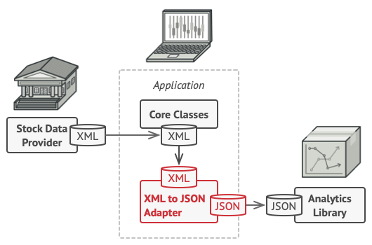

Let’s get back to our stock market app. To solve the dilemma of incompatible formats, you can create XML-to-JSON adapters for every class of the analytics library that your code works with directly. Then you adjust your code to communicate with the library only via these adapters. When an adapter receives a call, it translates the incoming XML data into a JSON structure and passes the call to the appropriate methods of a wrapped analytics object.

## Real-World Analogy

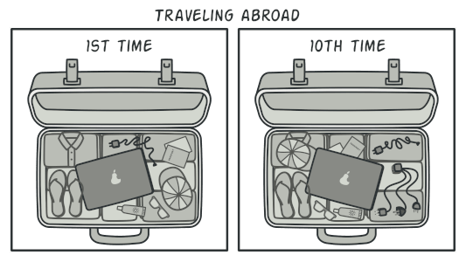

A suitcase before and after a trip abroad.

When you travel from the US to Europe for the first time, you may get a surprise when trying to charge your laptop. The power plug and sockets standards are different in different countries. That’s why your US plug won’t fit a German socket. The problem can be solved by using a power plug adapter that has the American-style socket and the European-style plug.

# Bridge

## Intent

**Bridge** is a structural design pattern that lets you split a large class or a set of closely related classes into two separate hierarchies—abstraction and implementation—which can be developed independently of each other.

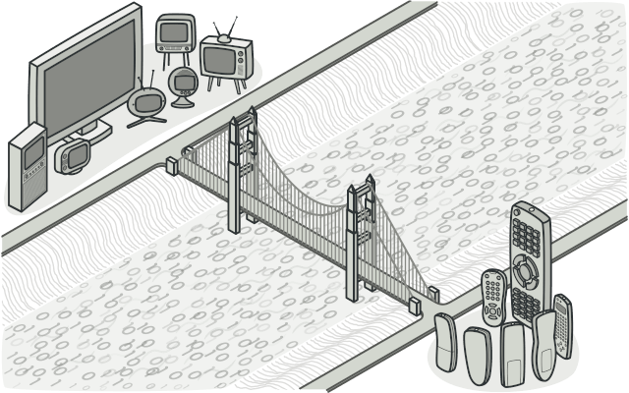

## Problem

Abstraction? Implementation? Sound scary? Stay calm and let’s consider a simple example.

Say you have a geometric Shape class with a pair of subclasses: Circle and Square. You want to extend this class hierarchy to incorporate colors, so you plan to create Red and Blue shape subclasses. However, since you already have two subclasses, you’ll need to create four class combinations such as BlueCircle and RedSquare.

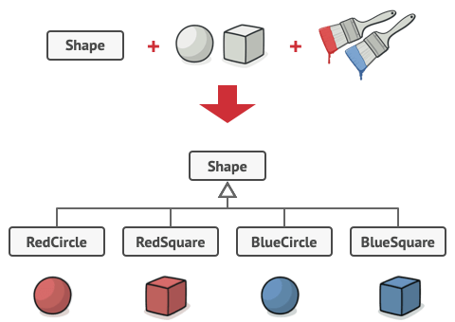

Number of class combinations grows in geometric progression.

Adding new shape types and colors to the hierarchy will grow it exponentially. For example, to add a triangle shape you’d need to introduce two subclasses, one for each color. And after that, adding a new color would require creating three subclasses, one for each shape type. The further we go, the worse it becomes.

## Solution

This problem occurs because we’re trying to extend the shape classes in two independent dimensions: by form and by color. That’s a very common issue with class inheritance.

The Bridge pattern attempts to solve this problem by switching from inheritance to the object composition. What this means is that you extract one of the dimensions into a separate class hierarchy, so that the original classes will reference an object of the new hierarchy, instead of having all of its state and behaviors within one class.

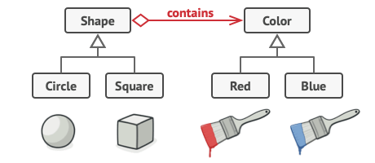

You can prevent the explosion of a class hierarchy by transforming it into several related hierarchies.

Following this approach, we can extract the color-related code into its own class with two subclasses: Red and Blue. The Shape class then gets a reference field pointing to one of the color objects. Now the shape can delegate any color-related work to the linked color object. That reference will act as a bridge between the Shape and Color classes. From now on, adding new colors won’t require changing the shape hierarchy, and vice versa.

#### Abstraction and Implementation

The GoF book  introduces the terms Abstraction and Implementation as part of the Bridge definition. In my opinion, the terms sound too academic and make the pattern seem more complicated than it really is. Having read the simple example with shapes and colors, let’s decipher the meaning behind the GoF book’s scary words.

Abstraction (also called interface) is a high-level control layer for some entity. This layer isn’t supposed to do any real work on its own. It should delegate the work to the implementation layer (also called platform).

Note that we’re not talking about interfaces or abstract classes from your programming language. These aren’t the same things.

When talking about real applications, the abstraction can be represented by a graphical user interface (GUI), and the implementation could be the underlying operating system code (API) which the GUI layer calls in response to user interactions.

Generally speaking, you can extend such an app in two independent directions:

* Have several different GUIs (for instance, tailored for regular customers or admins).
* Support several different APIs (for example, to be able to launch the app under Windows, Linux, and macOS).

In a worst-case scenario, this app might look like a giant spaghetti bowl, where hundreds of conditionals connect different types of GUI with various APIs all over the code.

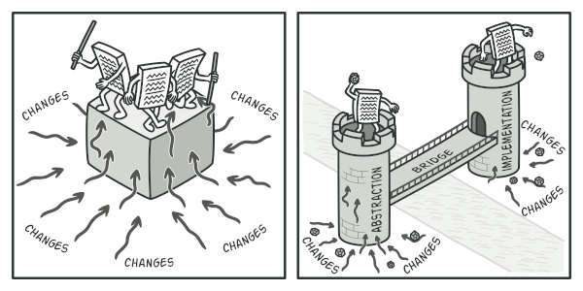

Making even a simple change to a monolithic codebase is pretty hard because you must understand the entire thing very well. Making changes to smaller, well-defined modules is much easier.

You can bring order to this chaos by extracting the code related to specific interface-platform combinations into separate classes. However, soon you’ll discover that there are lots of these classes. The class hierarchy will grow exponentially because adding a new GUI or supporting a different API would require creating more and more classes.

Let’s try to solve this issue with the Bridge pattern. It suggests that we divide the classes into two hierarchies:

* Abstraction: the GUI layer of the app.
* Implementation: the operating systems’ APIs.

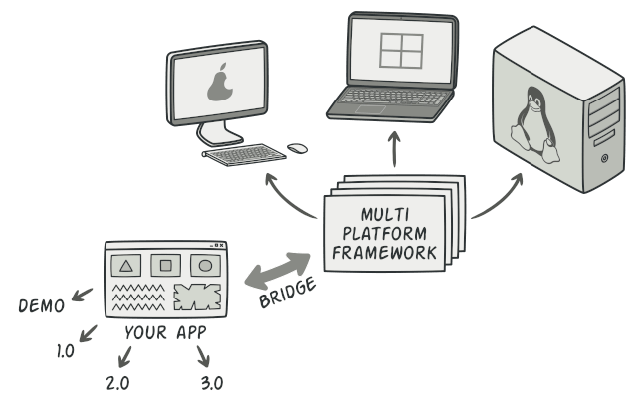

One of the ways to structure a cross-platform application.

The abstraction object controls the appearance of the app, delegating the actual work to the linked implementation object. Different implementations are interchangeable as long as they follow a common interface, enabling the same GUI to work under Windows and Linux.

As a result, you can change the GUI classes without touching the API-related classes. Moreover, adding support for another operating system only requires creating a subclass in the implementation hierarchy.

# Composite

**Also known as:**Object Tree

## Intent

**Composite** is a structural design pattern that lets you compose objects into tree structures and then work with these structures as if they were individual objects.

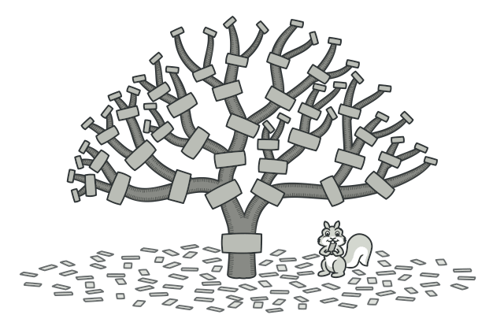

## Problem

Using the Composite pattern makes sense only when the core model of your app can be represented as a tree.

For example, imagine that you have two types of objects: Products and Boxes. A Box can contain several Products as well as a number of smaller Boxes. These little Boxes can also hold some Products or even smaller Boxes, and so on.

Say you decide to create an ordering system that uses these classes. Orders could contain simple products without any wrapping, as well as boxes stuffed with products...and other boxes. How would you determine the total price of such an order?

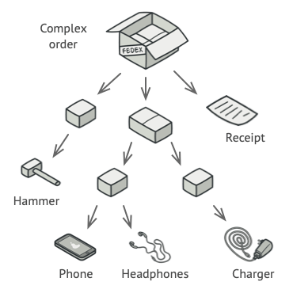

An order might comprise various products, packaged in boxes, which are packaged in bigger boxes and so on. The whole structure looks like an upside down tree.

You could try the direct approach: unwrap all the boxes, go over all the products and then calculate the total. That would be doable in the real world; but in a program, it’s not as simple as running a loop. You have to know the classes of Products and Boxes you’re going through, the nesting level of the boxes and other nasty details beforehand. All of this makes the direct approach either too awkward or even impossible.

## Solution

The Composite pattern suggests that you work with Products and Boxes through a common interface which declares a method for calculating the total price.

How would this method work? For a product, it’d simply return the product’s price. For a box, it’d go over each item the box contains, ask its price and then return a total for this box. If one of these items were a smaller box, that box would also start going over its contents and so on, until the prices of all inner components were calculated. A box could even add some extra cost to the final price, such as packaging cost.



The Composite pattern lets you run a behavior recursively over all components of an object tree.

The greatest benefit of this approach is that you don’t need to care about the concrete classes of objects that compose the tree. You don’t need to know whether an object is a simple product or a sophisticated box. You can treat them all the same via the common interface. When you call a method, the objects themselves pass the request down the tree.

## Real-World Analogy

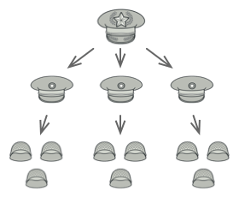

An example of a military structure.

Armies of most countries are structured as hierarchies. An army consists of several divisions; a division is a set of brigades, and a brigade consists of platoons, which can be broken down into squads. Finally, a squad is a small group of real soldiers. Orders are given at the top of the hierarchy and passed down onto each level until every soldier knows what needs to be done.

# Decorator

**Also known as:**Wrapper

## Intent

**Decorator** is a structural design pattern that lets you attach new behaviors to objects by placing these objects inside special wrapper objects that contain the behaviors.

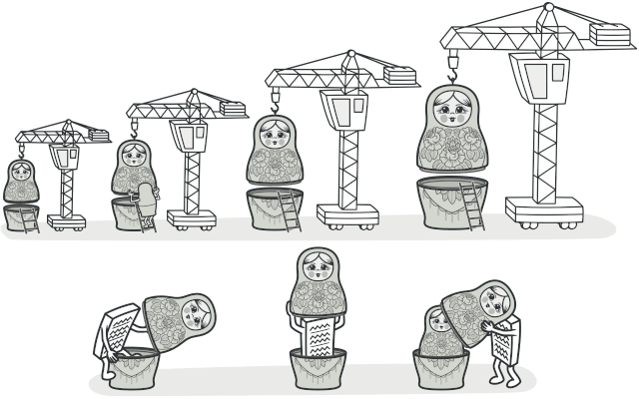

## Problem

Imagine that you’re working on a notification library which lets other programs notify their users about important events.

The initial version of the library was based on the Notifier class that had only a few fields, a constructor and a single send method. The method could accept a message argument from a client and send the message to a list of emails that were passed to the notifier via its constructor. A third-party app which acted as a client was supposed to create and configure the notifier object once, and then use it each time something important happened.

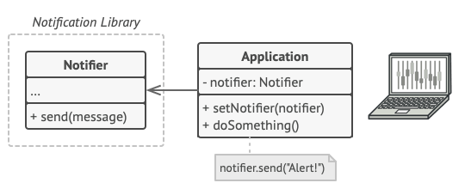

A program could use the notifier class to send notifications about important events to a predefined set of emails.

At some point, you realize that users of the library expect more than just email notifications. Many of them would like to receive an SMS about critical issues. Others would like to be notified on Facebook and, of course, the corporate users would love to get Slack notifications.

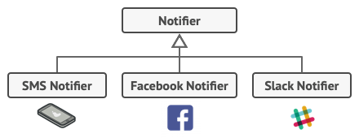

Each notification type is implemented as a notifier’s subclass.

How hard can that be? You extended the Notifier class and put the additional notification methods into new subclasses. Now the client was supposed to instantiate the desired notification class and use it for all further notifications.

But then someone reasonably asked you, “Why can’t you use several notification types at once? If your house is on fire, you’d probably want to be informed through every channel.”

You tried to address that problem by creating special subclasses which combined several notification methods within one class. However, it quickly became apparent that this approach would bloat the code immensely, not only the library code but the client code as well.

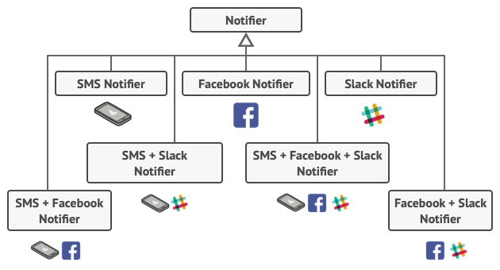

Combinatorial explosion of subclasses.

You have to find some other way to structure notifications classes so that their number won’t accidentally break some Guinness record.

## Solution

Extending a class is the first thing that comes to mind when you need to alter an object’s behavior. However, inheritance has several serious caveats that you need to be aware of.

* Inheritance is static. You can’t alter the behavior of an existing object at runtime. You can only replace the whole object with another one that’s created from a different subclass.
* Subclasses can have just one parent class. In most languages, inheritance doesn’t let a class inherit behaviors of multiple classes at the same time.

One of the ways to overcome these caveats is by using Aggregation or Composition  instead of Inheritance. Both of the alternatives work almost the same way: one object has a reference to another and delegates it some work, whereas with inheritance, the object itself is able to do that work, inheriting the behavior from its superclass.

With this new approach you can easily substitute the linked “helper” object with another, changing the behavior of the container at runtime. An object can use the behavior of various classes, having references to multiple objects and delegating them all kinds of work. Aggregation/composition is the key principle behind many design patterns, including Decorator. On that note, let’s return to the pattern discussion.

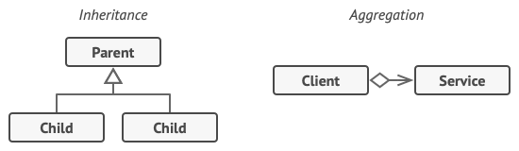

Inheritance vs. Aggregation

“Wrapper” is the alternative nickname for the Decorator pattern that clearly expresses the main idea of the pattern. A wrapper is an object that can be linked with some target object. The wrapper contains the same set of methods as the target and delegates to it all requests it receives. However, the wrapper may alter the result by doing something either before or after it passes the request to the target.

When does a simple wrapper become the real decorator? As I mentioned, the wrapper implements the same interface as the wrapped object. That’s why from the client’s perspective these objects are identical. Make the wrapper’s reference field accept any object that follows that interface. This will let you cover an object in multiple wrappers, adding the combined behavior of all the wrappers to it.

In our notifications example, let’s leave the simple email notification behavior inside the base Notifier class, but turn all other notification methods into decorators.

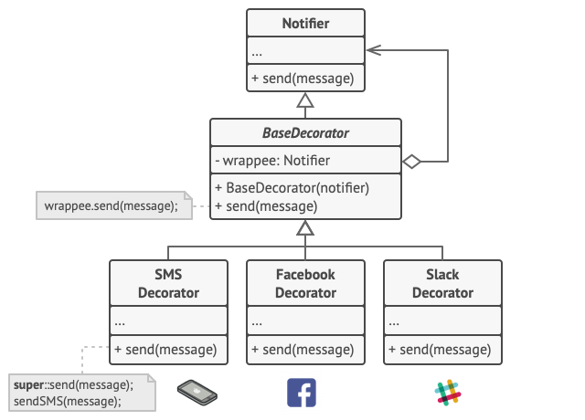

Various notification methods become decorators.

The client code would need to wrap a basic notifier object into a set of decorators that match the client’s preferences. The resulting objects will be structured as a stack.

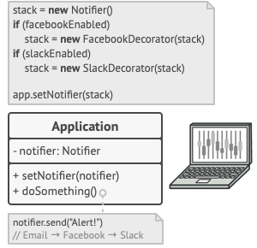

Apps might configure complex stacks of notification decorators.

The last decorator in the stack would be the object that the client actually works with. Since all decorators implement the same interface as the base notifier, the rest of the client code won’t care whether it works with the “pure” notifier object or the decorated one.

We could apply the same approach to other behaviors such as formatting messages or composing the recipient list. The client can decorate the object with any custom decorators, as long as they follow the same interface as the others.

## Real-World Analogy

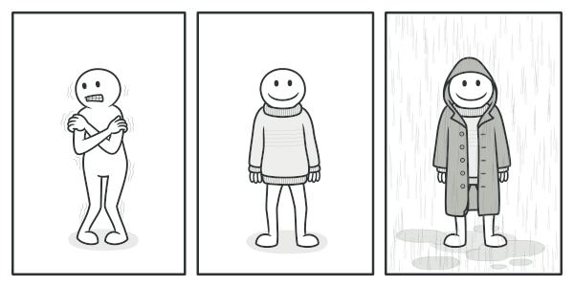

You get a combined effect from wearing multiple pieces of clothing.

Wearing clothes is an example of using decorators. When you’re cold, you wrap yourself in a sweater. If you’re still cold with a sweater, you can wear a jacket on top. If it’s raining, you can put on a raincoat. All of these garments “extend” your basic behavior but aren’t part of you, and you can easily take off any piece of clothing whenever you don’t need it.

# Facade

## Intent

**Facade** is a structural design pattern that provides a simplified interface to a library, a framework, or any other complex set of classes.

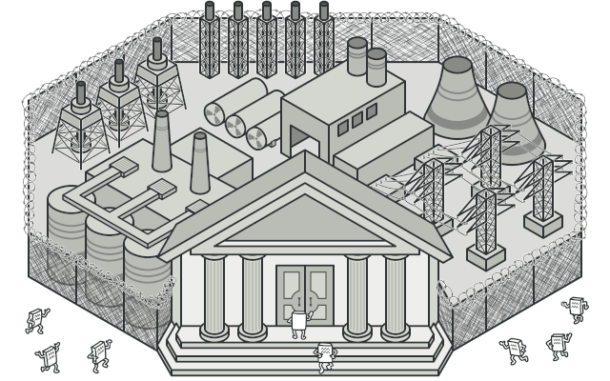

## Problem

Imagine that you must make your code work with a broad set of objects that belong to a sophisticated library or framework. Ordinarily, you’d need to initialize all of those objects, keep track of dependencies, execute methods in the correct order, and so on.

As a result, the business logic of your classes would become tightly coupled to the implementation details of 3rd-party classes, making it hard to comprehend and maintain.

## Solution

A facade is a class that provides a simple interface to a complex subsystem which contains lots of moving parts. A facade might provide limited functionality in comparison to working with the subsystem directly. However, it includes only those features that clients really care about.

Having a facade is handy when you need to integrate your app with a sophisticated library that has dozens of features, but you just need a tiny bit of its functionality.

For instance, an app that uploads short funny videos with cats to social media could potentially use a professional video conversion library. However, all that it really needs is a class with the single method encode(filename, format). After creating such a class and connecting it with the video conversion library, you’ll have your first facade.

## Real-World Analogy

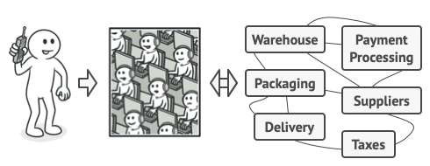

Placing orders by phone.

When you call a shop to place a phone order, an operator is your facade to all services and departments of the shop. The operator provides you with a simple voice interface to the ordering system, payment gateways, and various delivery services.

# Flyweight

**Also known as:**Cache

## Intent

**Flyweight** is a structural design pattern that lets you fit more objects into the available amount of RAM by sharing common parts of state between multiple objects instead of keeping all of the data in each object.

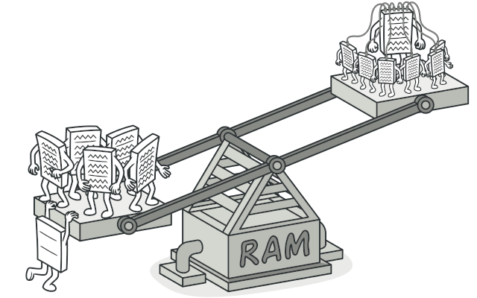

## Problem

To have some fun after long working hours, you decided to create a simple video game: players would be moving around a map and shooting each other. You chose to implement a realistic particle system and make it a distinctive feature of the game. Vast quantities of bullets, missiles, and shrapnel from explosions should fly all over the map and deliver a thrilling experience to the player.

Upon its completion, you pushed the last commit, built the game and sent it to your friend for a test drive. Although the game was running flawlessly on your machine, your friend wasn’t able to play for long. On his computer, the game kept crashing after a few minutes of gameplay. After spending several hours digging through debug logs, you discovered that the game crashed because of an insufficient amount of RAM. It turned out that your friend’s rig was much less powerful than your own computer, and that’s why the problem emerged so quickly on his machine.

The actual problem was related to your particle system. Each particle, such as a bullet, a missile or a piece of shrapnel was represented by a separate object containing plenty of data. At some point, when the carnage on a player’s screen reached its climax, newly created particles no longer fit into the remaining RAM, so the program crashed.

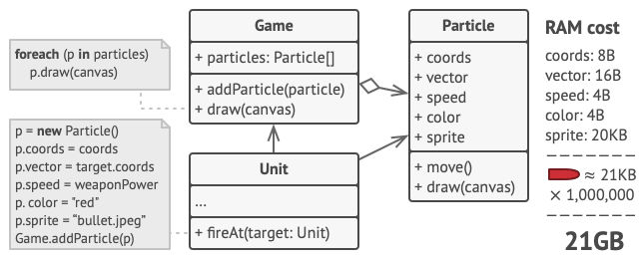

## Solution

On closer inspection of the Particle class, you may notice that the color and sprite fields consume a lot more memory than other fields. What’s worse is that these two fields store almost identical data across all particles. For example, all bullets have the same color and sprite.

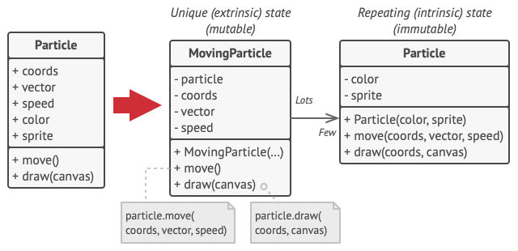

Other parts of a particle’s state, such as coordinates, movement vector and speed, are unique to each particle. After all, the values of these fields change over time. This data represents the always changing context in which the particle exists, while the color and sprite remain constant for each particle.

This constant data of an object is usually called the intrinsic state. It lives within the object; other objects can only read it, not change it. The rest of the object’s state, often altered “from the outside” by other objects, is called the extrinsic state.

The Flyweight pattern suggests that you stop storing the extrinsic state inside the object. Instead, you should pass this state to specific methods which rely on it. Only the intrinsic state stays within the object, letting you reuse it in different contexts. As a result, you’d need fewer of these objects since they only differ in the intrinsic state, which has much fewer variations than the extrinsic.

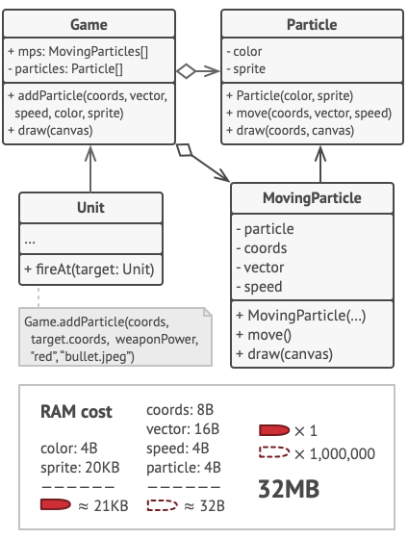

Let’s return to our game. Assuming that we had extracted the extrinsic state from our particle class, only three different objects would suffice to represent all particles in the game: a bullet, a missile, and a piece of shrapnel. As you’ve probably guessed by now, an object that only stores the intrinsic state is called a flyweight.

#### Extrinsic state storage

Where does the extrinsic state move to? Some class should still store it, right? In most cases, it gets moved to the container object, which aggregates objects before we apply the pattern.

In our case, that’s the main Game object that stores all particles in the particles field. To move the extrinsic state into this class, you need to create several array fields for storing coordinates, vectors, and speed of each individual particle. But that’s not all. You need another array for storing references to a specific flyweight that represents a particle. These arrays must be in sync so that you can access all data of a particle using the same index.

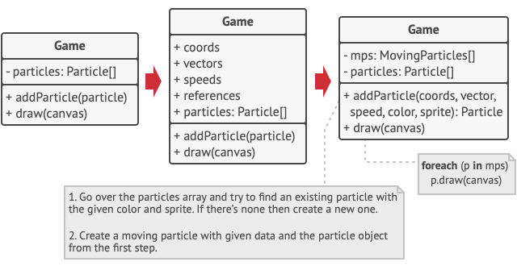

A more elegant solution is to create a separate context class that would store the extrinsic state along with reference to the flyweight object. This approach would require having just a single array in the container class.

Wait a second! Won’t we need to have as many of these contextual objects as we had at the very beginning? Technically, yes. But the thing is, these objects are much smaller than before. The most memory-consuming fields have been moved to just a few flyweight objects. Now, a thousand small contextual objects can reuse a single heavy flyweight object instead of storing a thousand copies of its data.

#### Flyweight and immutability

Since the same flyweight object can be used in different contexts, you have to make sure that its state can’t be modified. A flyweight should initialize its state just once, via constructor parameters. It shouldn’t expose any setters or public fields to other objects.

#### Flyweight factory

For more convenient access to various flyweights, you can create a factory method that manages a pool of existing flyweight objects. The method accepts the intrinsic state of the desired flyweight from a client, looks for an existing flyweight object matching this state, and returns it if it was found. If not, it creates a new flyweight and adds it to the pool.

There are several options where this method could be placed. The most obvious place is a flyweight container. Alternatively, you could create a new factory class. Or you could make the factory method static and put it inside an actual flyweight class.

# Proxy

## Intent

**Proxy** is a structural design pattern that lets you provide a substitute or placeholder for another object. A proxy controls access to the original object, allowing you to perform something either before or after the request gets through to the original object.

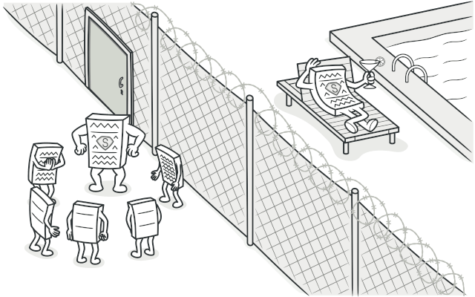

## Problem

Why would you want to control access to an object? Here is an example: you have a massive object that consumes a vast amount of system resources. You need it from time to time, but not always.

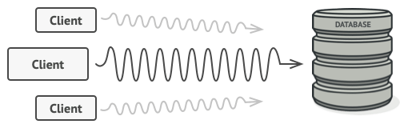

Database queries can be really slow.

You could implement lazy initialization: create this object only when it’s actually needed. All of the object’s clients would need to execute some deferred initialization code. Unfortunately, this would probably cause a lot of code duplication.

In an ideal world, we’d want to put this code directly into our object’s class, but that isn’t always possible. For instance, the class may be part of a closed 3rd-party library.

## Solution

The Proxy pattern suggests that you create a new proxy class with the same interface as an original service object. Then you update your app so that it passes the proxy object to all of the original object’s clients. Upon receiving a request from a client, the proxy creates a real service object and delegates all the work to it.

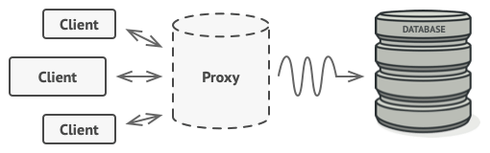

The proxy disguises itself as a database object. It can handle lazy initialization and result caching without the client or the real database object even knowing.

But what’s the benefit? If you need to execute something either before or after the primary logic of the class, the proxy lets you do this without changing that class. Since the proxy implements the same interface as the original class, it can be passed to any client that expects a real service object.

## Real-World Analogy

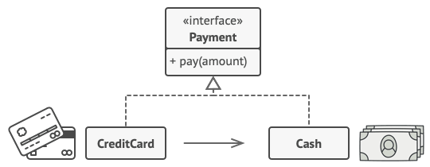

Credit cards can be used for payments just the same as cash.

A credit card is a proxy for a bank account, which is a proxy for a bundle of cash. Both implement the same interface: they can be used for making a payment. A consumer feels great because there’s no need to carry loads of cash around. A shop owner is also happy since the income from a transaction gets added electronically to the shop’s bank account without the risk of losing the deposit or getting robbed on the way to the bank.

# Private Class Data

### Intent

* Control write access to class attributes
* Separate data from methods that use it
* Encapsulate class data initialization
* Providing new type of final - *final after constructor*

### Problem

A class may expose its attributes (class variables) to manipulation when manipulation is no longer desirable, e.g. after construction. Using the private class data design pattern prevents that undesirable manipulation.

A class may have one-time mutable attributes that cannot be declared final. Using this design pattern allows one-time setting of those class attributes.

The motivation for this design pattern comes from the design goal of protecting class state by minimizing the visibility of its attributes (data).

### Discussion

The private class data design pattern seeks to reduce exposure of attributes by limiting their visibility.

It reduces the number of class attributes by encapsulating them in single Data object. It allows the class designer to remove write privilege of attributes that are intended to be set only during construction, even from methods of the target class.

# Behavioral Design Patterns

Has many types chain of responsibility, command, interpreter , Iterator, mediator, memento, null object, observer

# Chain of Responsibility

**Also known as:**CoR, Chain of Command

## Intent

**Chain of Responsibility** is a behavioral design pattern that lets you pass requests along a chain of handlers. Upon receiving a request, each handler decides either to process the request or to pass it to the next handler in the chain.

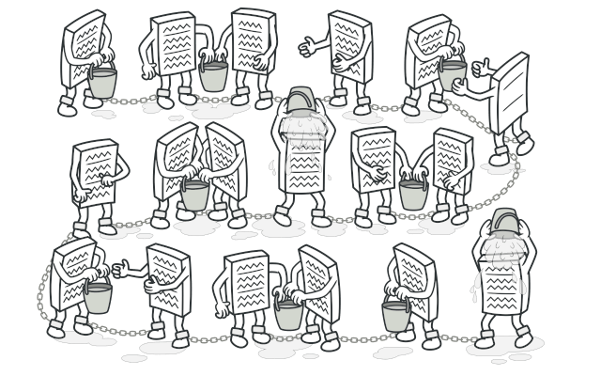

## Problem

Imagine that you’re working on an online ordering system. You want to restrict access to the system so only authenticated users can create orders. Also, users who have administrative permissions must have full access to all orders.

After a bit of planning, you realized that these checks must be performed sequentially. The application can attempt to authenticate a user to the system whenever it receives a request that contains the user’s credentials. However, if those credentials aren’t correct and authentication fails, there’s no reason to proceed with any other checks.

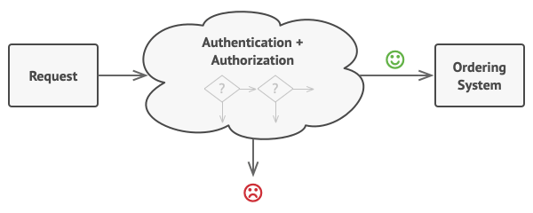

The request must pass a series of checks before the ordering system itself can handle it.

During the next few months, you implemented several more of those sequential checks.

* One of your colleagues suggested that it’s unsafe to pass raw data straight to the ordering system. So you added an extra validation step to sanitize the data in a request.
* Later, somebody noticed that the system is vulnerable to brute force password cracking. To negate this, you promptly added a check that filters repeated failed requests coming from the same IP address.
* Someone else suggested that you could speed up the system by returning cached results on repeated requests containing the same data. Hence, you added another check which lets the request pass through to the system only if there’s no suitable cached response.

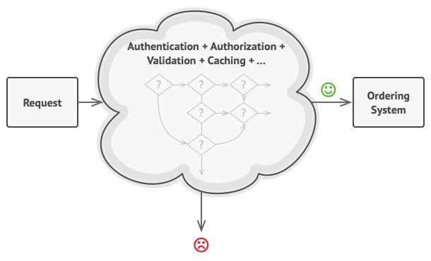

The bigger the code grew, the messier it became.

The code of the checks, which had already looked like a mess, became more and more bloated as you added each new feature. Changing one check sometimes affected the others. Worst of all, when you tried to reuse the checks to protect other components of the system, you had to duplicate some of the code since those components required some of the checks, but not all of them.

The system became very hard to comprehend and expensive to maintain. You struggled with the code for a while, until one day you decided to refactor the whole thing.

## Solution

Like many other behavioral design patterns, the **Chain of Responsibility** relies on transforming particular behaviors into stand-alone objects called handlers. In our case, each check should be extracted to its own class with a single method that performs the check. The request, along with its data, is passed to this method as an argument.

The pattern suggests that you link these handlers into a chain. Each linked handler has a field for storing a reference to the next handler in the chain. In addition to processing a request, handlers pass the request further along the chain. The request travels along the chain until all handlers have had a chance to process it.

Here’s the best part: a handler can decide not to pass the request further down the chain and effectively stop any further processing.

In our example with ordering systems, a handler performs the processing and then decides whether to pass the request further down the chain. Assuming the request contains the right data, all the handlers can execute their primary behavior, whether it’s authentication checks or caching.

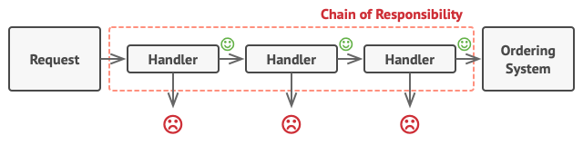

Handlers are lined up one by one, forming a chain.

However, there’s a slightly different approach (and it’s a bit more canonical) in which, upon receiving a request, a handler decides whether it can process it. If it can, it doesn’t pass the request any further. So it’s either only one handler that processes the request or none at all. This approach is very common when dealing with events in stacks of elements within a graphical user interface.

For instance, when a user clicks a button, the event propagates through the chain of GUI elements that starts with the button, goes along its containers (like forms or panels), and ends up with the main application window. The event is processed by the first element in the chain that’s capable of handling it. This example is also noteworthy because it shows that a chain can always be extracted from an object tree.

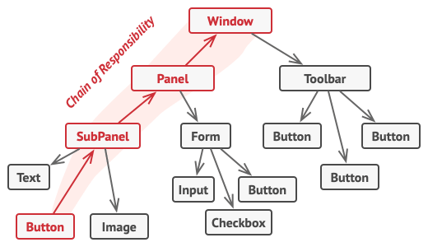

A chain can be formed from a branch of an object tree.

It’s crucial that all handler classes implement the same interface. Each concrete handler should only care about the following one having the execute method. This way you can compose chains at runtime, using various handlers without coupling your code to their concrete classes.

## Real-World Analogy

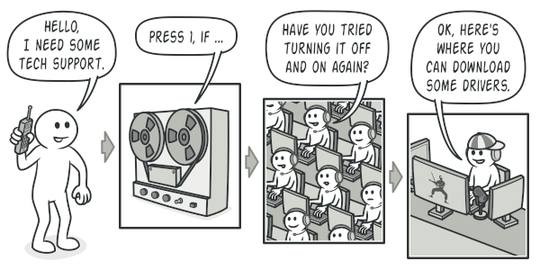

A call to tech support can go through multiple operators.

You’ve just bought and installed a new piece of hardware on your computer. Since you’re a geek, the computer has several operating systems installed. You try to boot all of them to see whether the hardware is supported. Windows detects and enables the hardware automatically. However, your beloved Linux refuses to work with the new hardware. With a small flicker of hope, you decide to call the tech-support phone number written on the box.

The first thing you hear is the robotic voice of the autoresponder. It suggests nine popular solutions to various problems, none of which are relevant to your case. After a while, the robot connects you to a live operator.

Alas, the operator isn’t able to suggest anything specific either. He keeps quoting lengthy excerpts from the manual, refusing to listen to your comments. After hearing the phrase “have you tried turning the computer off and on again?” for the 10th time, you demand to be connected to a proper engineer.

Eventually, the operator passes your call to one of the engineers, who had probably longed for a live human chat for hours as he sat in his lonely server room in the dark basement of some office building. The engineer tells you where to download proper drivers for your new hardware and how to install them on Linux. Finally, the solution! You end the call, bursting with joy.

# Command

**Also known as:**Action, Transaction

## Intent

**Command** is a behavioral design pattern that turns a request into a stand-alone object that contains all information about the request. This transformation lets you pass requests as a method arguments, delay or queue a request’s execution, and support undoable operations.

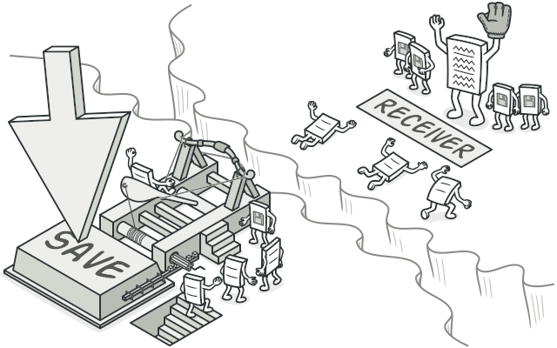

## Problem

Imagine that you’re working on a new text-editor app. Your current task is to create a toolbar with a bunch of buttons for various operations of the editor. You created a very neat Button class that can be used for buttons on the toolbar, as well as for generic buttons in various dialogs.

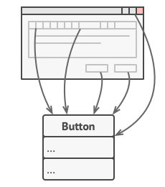

All buttons of the app are derived from the same class.

While all of these buttons look similar, they’re all supposed to do different things. Where would you put the code for the various click handlers of these buttons? The simplest solution is to create tons of subclasses for each place where the button is used. These subclasses would contain the code that would have to be executed on a button click.

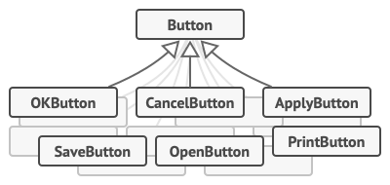

Lots of button subclasses. What can go wrong?

Before long, you realize that this approach is deeply flawed. First, you have an enormous number of subclasses, and that would be okay if you weren’t risking breaking the code in these subclasses each time you modify the base Button class. Put simply, your GUI code has become awkwardly dependent on the volatile code of the business logic.

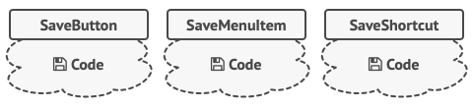

Several classes implement the same functionality.

And here’s the ugliest part. Some operations, such as copying/pasting text, would need to be invoked from multiple places. For example, a user could click a small “Copy” button on the toolbar, or copy something via the context menu, or just hit Ctrl+C on the keyboard.

Initially, when our app only had the toolbar, it was okay to place the implementation of various operations into the button subclasses. In other words, having the code for copying text inside the CopyButton subclass was fine. But then, when you implement context menus, shortcuts, and other stuff, you have to either duplicate the operation’s code in many classes or make menus dependent on buttons, which is an even worse option.

## Solution

Good software design is often based on the principle of separation of concerns, which usually results in breaking an app into layers. The most common example: a layer for the graphical user interface and another layer for the business logic. The GUI layer is responsible for rendering a beautiful picture on the screen, capturing any input and showing results of what the user and the app are doing. However, when it comes to doing something important, like calculating the trajectory of the moon or composing an annual report, the GUI layer delegates the work to the underlying layer of business logic.

In the code it might look like this: a GUI object calls a method of a business logic object, passing it some arguments. This process is usually described as one object sending another a request.

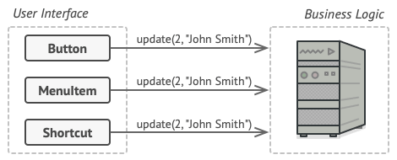

The GUI objects may access the business logic objects directly.

The Command pattern suggests that GUI objects shouldn’t send these requests directly. Instead, you should extract all of the request details, such as the object being called, the name of the method and the list of arguments into a separate command class with a single method that triggers this request.

Command objects serve as links between various GUI and business logic objects. From now on, the GUI object doesn’t need to know what business logic object will receive the request and how it’ll be processed. The GUI object just triggers the command, which handles all the details.

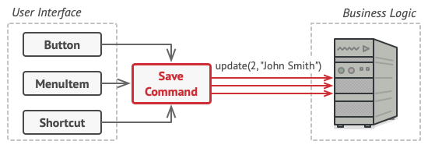

Accessing the business logic layer via a command.

The next step is to make your commands implement the same interface. Usually it has just a single execution method that takes no parameters. This interface lets you use various commands with the same request sender, without coupling it to concrete classes of commands. As a bonus, now you can switch command objects linked to the sender, effectively changing the sender’s behavior at runtime.

You might have noticed one missing piece of the puzzle, which is the request parameters. A GUI object might have supplied the business-layer object with some parameters. Since the command execution method doesn’t have any parameters, how would we pass the request details to the receiver? It turns out the command should be either pre-configured with this data, or capable of getting it on its own.

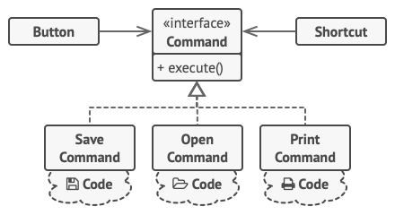

The GUI objects delegate the work to commands.

Let’s get back to our text editor. After we apply the Command pattern, we no longer need all those button subclasses to implement various click behaviors. It’s enough to put a single field into the base Button class that stores a reference to a command object and make the button execute that command on a click.

You’ll implement a bunch of command classes for every possible operation and link them with particular buttons, depending on the buttons’ intended behavior.

Other GUI elements, such as menus, shortcuts or entire dialogs, can be implemented in the same way. They’ll be linked to a command which gets executed when a user interacts with the GUI element. As you’ve probably guessed by now, the elements related to the same operations will be linked to the same commands, preventing any code duplication.

As a result, commands become a convenient middle layer that reduces coupling between the GUI and business logic layers. And that’s only a fraction of the benefits that the Command pattern can offer!

## Real-World Analogy

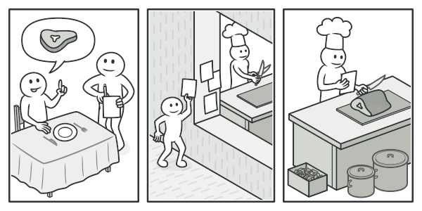

Making an order in a restaurant.

After a long walk through the city, you get to a nice restaurant and sit at the table by the window. A friendly waiter approaches you and quickly takes your order, writing it down on a piece of paper. The waiter goes to the kitchen and sticks the order on the wall. After a while, the order gets to the chef, who reads it and cooks the meal accordingly. The cook places the meal on a tray along with the order. The waiter discovers the tray, checks the order to make sure everything is as you wanted it, and brings everything to your table.

The paper order serves as a command. It remains in a queue until the chef is ready to serve it. The order contains all the relevant information required to cook the meal. It allows the chef to start cooking right away instead of running around clarifying the order details from you directly.

# Iterator

## Intent

**Iterator** is a behavioral design pattern that lets you traverse elements of a collection without exposing its underlying representation (list, stack, tree, etc.).

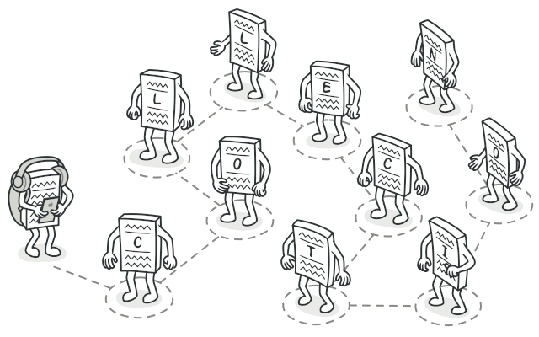

## Problem

Collections are one of the most used data types in programming. Nonetheless, a collection is just a container for a group of objects.

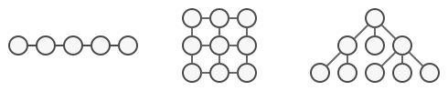

Various types of collections.

Most collections store their elements in simple lists. However, some of them are based on stacks, trees, graphs and other complex data structures.

But no matter how a collection is structured, it must provide some way of accessing its elements so that other code can use these elements. There should be a way to go through each element of the collection without accessing the same elements over and over.

This may sound like an easy job if you have a collection based on a list. You just loop over all of the elements. But how do you sequentially traverse elements of a complex data structure, such as a tree? For example, one day you might be just fine with depth-first traversal of a tree. Yet the next day you might require breadth-first traversal. And the next week, you might need something else, like random access to the tree elements.

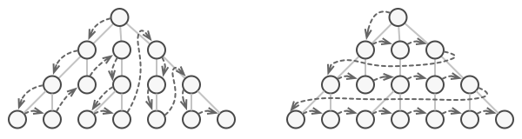

The same collection can be traversed in several different ways.

Adding more and more traversal algorithms to the collection gradually blurs its primary responsibility, which is efficient data storage. Additionally, some algorithms might be tailored for a specific application, so including them into a generic collection class would be weird.

On the other hand, the client code that’s supposed to work with various collections may not even care how they store their elements. However, since collections all provide different ways of accessing their elements, you have no option other than to couple your code to the specific collection classes.

## Solution

The main idea of the Iterator pattern is to extract the traversal behavior of a collection into a separate object called an iterator.

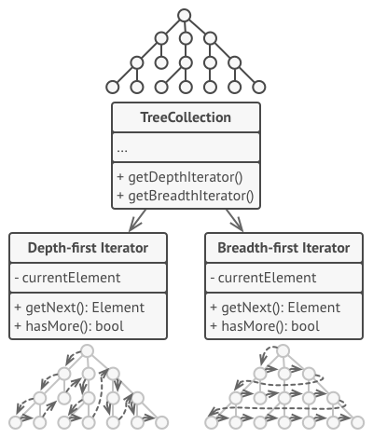

Iterators implement various traversal algorithms. Several iterator objects can traverse the same collection at the same time.

In addition to implementing the algorithm itself, an iterator object encapsulates all of the traversal details, such as the current position and how many elements are left till the end. Because of this, several iterators can go through the same collection at the same time, independently of each other.

Usually, iterators provide one primary method for fetching elements of the collection. The client can keep running this method until it doesn’t return anything, which means that the iterator has traversed all of the elements.

All iterators must implement the same interface. This makes the client code compatible with any collection type or any traversal algorithm as long as there’s a proper iterator. If you need a special way to traverse a collection, you just create a new iterator class, without having to change the collection or the client.

## Real-World Analogy

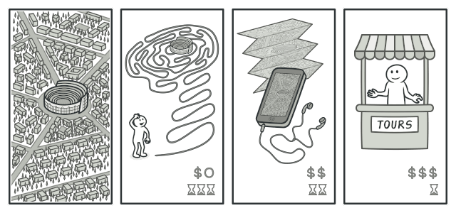

Various ways to walk around Rome.

You plan to visit Rome for a few days and visit all of its main sights and attractions. But once there, you could waste a lot of time walking in circles, unable to find even the Colosseum.

On the other hand, you could buy a virtual guide app for your smartphone and use it for navigation. It’s smart and inexpensive, and you could be staying at some interesting places for as long as you want.

A third alternative is that you could spend some of the trip’s budget and hire a local guide who knows the city like the back of his hand. The guide would be able to tailor the tour to your likings, show you every attraction and tell a lot of exciting stories. That’ll be even more fun; but, alas, more expensive, too.

All of these options—the random directions born in your head, the smartphone navigator or the human guide—act as iterators over the vast collection of sights and attractions located in Rome.

## Structure

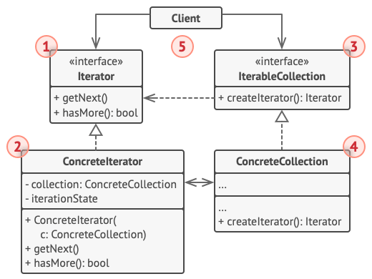

1. The **Iterator** interface declares the operations required for traversing a collection: fetching the next element, retrieving the current position, restarting iteration, etc.
2. **Concrete Iterators** implement specific algorithms for traversing a collection. The iterator object should track the traversal progress on its own. This allows several iterators to traverse the same collection independently of each other.
3. The **Collection** interface declares one or multiple methods for getting iterators compatible with the collection. Note that the return type of the methods must be declared as the iterator interface so that the concrete collections can return various kinds of iterators.
4. **Concrete Collections** return new instances of a particular concrete iterator class each time the client requests one. You might be wondering, where’s the rest of the collection’s code? Don’t worry, it should be in the same class. It’s just that these details aren’t crucial to the actual pattern, so we’re omitting them.
5. The **Client** works with both collections and iterators via their interfaces. This way the client isn’t coupled to concrete classes, allowing you to use various collections and iterators with the same client code.

Typically, clients don’t create iterators on their own, but instead get them from collections. Yet, in certain cases, the client can create one directly; for example, when the client defines its own special iterator.

## Interpreter Design Pattern

Interpreter design pattern is one of the **behavioral** design pattern. Interpreter pattern is used to defines a grammatical representation for a language and provides an interpreter to deal with this grammar.

* This pattern involves implementing an expression interface which tells to interpret a particular context. This pattern is used in SQL parsing, symbol processing engine etc.
* This pattern performs upon a hierarchy of expressions. Each expression here is a terminal or non-terminal.
* The tree structure of Interpreter design pattern is somewhat similar to that defined by the composite design pattern with terminal expressions being leaf objects and non-terminal expressions being composites.
* The tree contains the expressions to be evaluated and is usually generated by a parser. The parser itself is not a part of the interpreter pattern.

For Example :  
Here is the hierarchy of expressions for **“+ – 9 8 7”** :  
[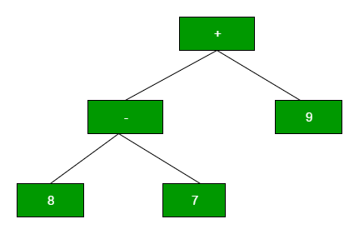](https://media.geeksforgeeks.org/wp-content/uploads/interpreter-pattern-1.png)

# Mediator

**Also known as:**Intermediary, Controller

## Intent

**Mediator** is a behavioral design pattern that lets you reduce chaotic dependencies between objects. The pattern restricts direct communications between the objects and forces them to collaborate only via a mediator object.

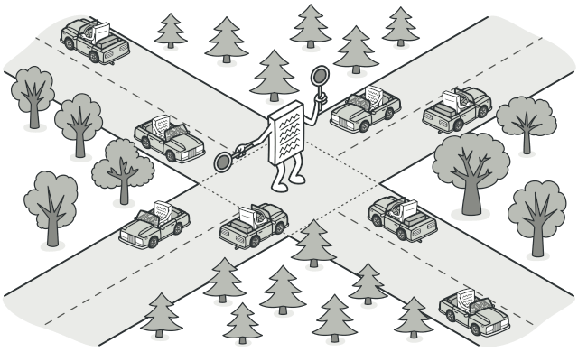

## Problem

Say you have a dialog for creating and editing customer profiles. It consists of various form controls such as text fields, checkboxes, buttons, etc.

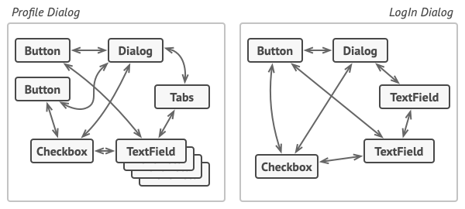

Relations between elements of the user interface can become chaotic as the application evolves.

Some of the form elements may interact with others. For instance, selecting the “I have a dog” checkbox may reveal a hidden text field for entering the dog’s name. Another example is the submit button that has to validate values of all fields before saving the data.

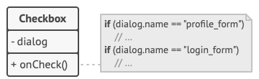

Elements can have lots of relations with other elements. Hence, changes to some elements may affect the others.

By having this logic implemented directly inside the code of the form elements you make these elements’ classes much harder to reuse in other forms of the app. For example, you won’t be able to use that checkbox class inside another form, because it’s coupled to the dog’s text field. You can use either all the classes involved in rendering the profile form, or none at all.

## Solution

The Mediator pattern suggests that you should cease all direct communication between the components which you want to make independent of each other. Instead, these components must collaborate indirectly, by calling a special mediator object that redirects the calls to appropriate components. As a result, the components depend only on a single mediator class instead of being coupled to dozens of their colleagues.

In our example with the profile editing form, the dialog class itself may act as the mediator. Most likely, the dialog class is already aware of all of its sub-elements, so you won’t even need to introduce new dependencies into this class.

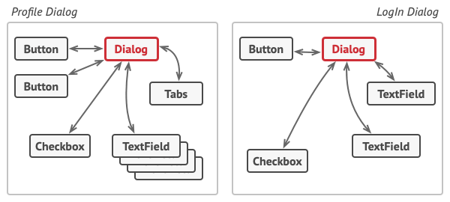

UI elements should communicate indirectly, via the mediator object.

The most significant change happens to the actual form elements. Let’s consider the submit button. Previously, each time a user clicked the button, it had to validate the values of all individual form elements. Now its single job is to notify the dialog about the click. Upon receiving this notification, the dialog itself performs the validations or passes the task to the individual elements. Thus, instead of being tied to a dozen form elements, the button is only dependent on the dialog class.

You can go further and make the dependency even looser by extracting the common interface for all types of dialogs. The interface would declare the notification method which all form elements can use to notify the dialog about events happening to those elements. Thus, our submit button should now be able to work with any dialog that implements that interface.

This way, the Mediator pattern lets you encapsulate a complex web of relations between various objects inside a single mediator object. The fewer dependencies a class has, the easier it becomes to modify, extend or reuse that class.

## Real-World Analogy

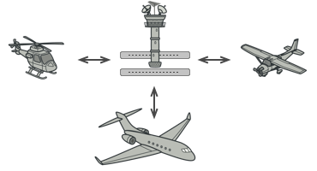

Aircraft pilots don’t talk to each other directly when deciding who gets to land their plane next. All communication goes through the control tower.

Pilots of aircraft that approach or depart the airport control area don’t communicate directly with each other. Instead, they speak to an air traffic controller, who sits in a tall tower somewhere near the airstrip. Without the air traffic controller, pilots would need to be aware of every plane in the vicinity of the airport, discussing landing priorities with a committee of dozens of other pilots. That would probably skyrocket the airplane crash statistics.

The tower doesn’t need to control the whole flight. It exists only to enforce constraints in the terminal area because the number of involved actors there might be overwhelming to a pilot.

# Memento

**Also known as:**Snapshot

## Intent

**Memento** is a behavioral design pattern that lets you save and restore the previous state of an object without revealing the details of its implementation.

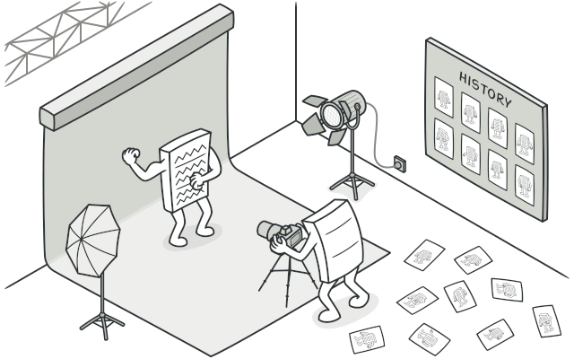

## Problem

Imagine that you’re creating a text editor app. In addition to simple text editing, your editor can format text, insert inline images, etc.

At some point, you decided to let users undo any operations carried out on the text. This feature has become so common over the years that nowadays people expect every app to have it. For the implementation, you chose to take the direct approach. Before performing any operation, the app records the state of all objects and saves it in some storage. Later, when a user decides to revert an action, the app fetches the latest snapshot from the history and uses it to restore the state of all objects.

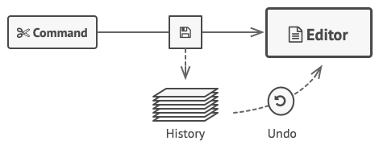

Before executing an operation, the app saves a snapshot of the objects’ state, which can later be used to restore objects to their previous state.

Let’s think about those state snapshots. How exactly would you produce one? You’d probably need to go over all the fields in an object and copy their values into storage. However, this would only work if the object had quite relaxed access restrictions to its contents. Unfortunately, most real objects won’t let others peek inside them that easily, hiding all significant data in private fields.

Ignore that problem for now and let’s assume that our objects behave like hippies: preferring open relations and keeping their state public. While this approach would solve the immediate problem and let you produce snapshots of objects’ states at will, it still has some serious issues. In the future, you might decide to refactor some of the editor classes, or add or remove some of the fields. Sounds easy, but this would also require changing the classes responsible for copying the state of the affected objects.

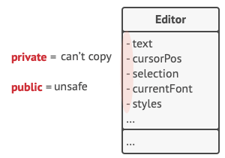

How to make a copy of the object’s private state?

But there’s more. Let’s consider the actual “snapshots” of the editor’s state. What data does it contain? At a bare minimum, it must contain the actual text, cursor coordinates, current scroll position, etc. To make a snapshot, you’d need to collect these values and put them into some kind of container.

Most likely, you’re going to store lots of these container objects inside some list that would represent the history. Therefore the containers would probably end up being objects of one class. The class would have almost no methods, but lots of fields that mirror the editor’s state. To allow other objects to write and read data to and from a snapshot, you’d probably need to make its fields public. That would expose all the editor’s states, private or not. Other classes would become dependent on every little change to the snapshot class, which would otherwise happen within private fields and methods without affecting outer classes.

It looks like we’ve reached a dead end: you either expose all internal details of classes, making them too fragile, or restrict access to their state, making it impossible to produce snapshots. Is there any other way to implement the "undo"?

## Solution

All problems that we’ve just experienced are caused by broken encapsulation. Some objects try to do more than they are supposed to. To collect the data required to perform some action, they invade the private space of other objects instead of letting these objects perform the actual action.

The Memento pattern delegates creating the state snapshots to the actual owner of that state, the originator object. Hence, instead of other objects trying to copy the editor’s state from the “outside,” the editor class itself can make the snapshot since it has full access to its own state.

The pattern suggests storing the copy of the object’s state in a special object called memento. The contents of the memento aren’t accessible to any other object except the one that produced it. Other objects must communicate with mementos using a limited interface which may allow fetching the snapshot’s metadata (creation time, the name of the performed operation, etc.), but not the original object’s state contained in the snapshot.

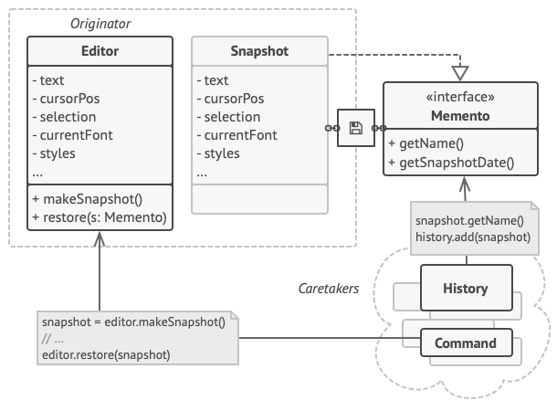

The originator has full access to the memento, whereas the caretaker can only access the metadata.

Such a restrictive policy lets you store mementos inside other objects, usually called caretakers. Since the caretaker works with the memento only via the limited interface, it’s not able to tamper with the state stored inside the memento. At the same time, the originator has access to all fields inside the memento, allowing it to restore its previous state at will.

In our text editor example, we can create a separate history class to act as the caretaker. A stack of mementos stored inside the caretaker will grow each time the editor is about to execute an operation. You could even render this stack within the app’s UI, displaying the history of previously performed operations to a user.

When a user triggers the undo, the history grabs the most recent memento from the stack and passes it back to the editor, requesting a roll-back. Since the editor has full access to the memento, it changes its own state with the values taken from the memento.

# ****Null Object**** Design Pattern

### Intent

The intent of a Null Object is to encapsulate the absence of an object by providing a substitutable alternative that offers suitable default do nothing behavior. In short, a design where "nothing will come of nothing"

Use the Null Object pattern when

* an object requires a collaborator. The Null Object pattern does not introduce this collaboration--it makes use of a collaboration that already exists
* some collaborator instances should do nothing
* you want to abstract the handling of null away from the client

### Problem

Given that an object reference may be optionally null, and that the result of a null check is to do nothing or use some default value, how can the absence of an object — the presence of a null reference — be treated transparently?

### Discussion

Sometimes a class that requires a collaborator does not need the collaborator to do anything. However, the class wishes to treat a collaborator that does nothing the same way it treats one that actually provides behavior.

Consider for example a simple screen saver which displays balls that move about the screen and have special color effects. This is easily achieved by creating a Ball class to represent the balls and using a Strategy pattern to control the ball's motion and another Strategy pattern to control the ball's color.

It would then be trivial to write strategies for many different types of motion and color effects and create balls with any combination of those. However, to start with you want to create the simplest strategies possible to make sure everything is working. And these strategies could also be useful later since you want as strategies as possible strategies.

## Observer

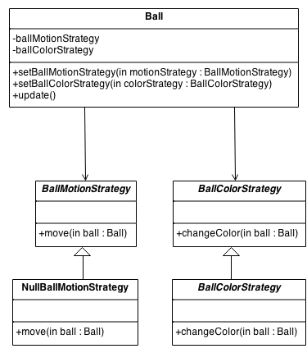

Now, the simplest strategy would be no strategy. That is do nothing, don't move and don't change color. However, the Strategy pattern requires the ball to have objects which implement the strategy interfaces. This is where the Null Object pattern becomes useful.

Simply implement a NullMovementStrategy which doesn't move the ball and a NullColorStrategy which doesn't change the ball's color. Both of these can probably be implemented with essentially no code. All the methods in these classes do "nothing". They are perfect examples of the Null Object Pattern.

The key to the Null Object pattern is an abstract class that defines the interface for all objects of this type. The Null Object is implemented as a subclass of this abstract class. Because it conforms to the abstract class' interface, it can be used any place this type of object is needed. As compared to using a special "null" value which doesn't actually implement the abstract interface and which must constantly be checked for with special code in any object which uses the abstract interface.

It is sometimes thought that Null Objects are over simple and "stupid" but in truth a Null Object always knows exactly what needs to be done without interacting with any other objects. So in truth it is very "smart.

**Also known as:**Event-Subscriber, Listener

## Intent

**Observer** is a behavioral design pattern that lets you define a subscription mechanism to notify multiple objects about any events that happen to the object they’re observing.

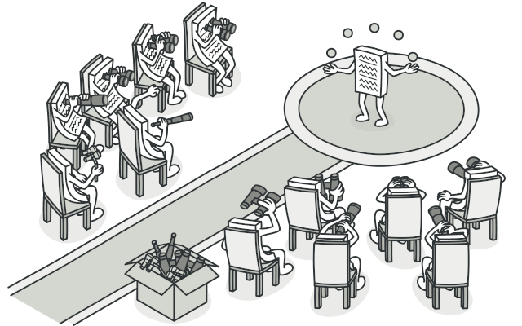

## Problem

Imagine that you have two types of objects: a Customer and a Store. The customer is very interested in a particular brand of product (say, it’s a new model of the iPhone) which should become available in the store very soon.

The customer could visit the store every day and check product availability. But while the product is still en route, most of these trips would be pointless.

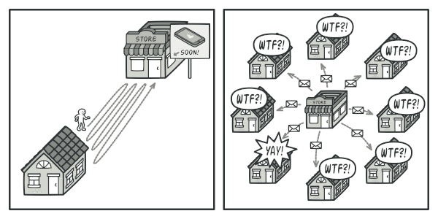

Visiting the store vs. sending spam

On the other hand, the store could send tons of emails (which might be considered spam) to all customers each time a new product becomes available. This would save some customers from endless trips to the store. At the same time, it’d upset other customers who aren’t interested in new products.

It looks like we’ve got a conflict. Either the customer wastes time checking product availability or the store wastes resources notifying the wrong customers.

## Solution

The object that has some interesting state is often called subject, but since it’s also going to notify other objects about the changes to its state, we’ll call it publisher. All other objects that want to track changes to the publisher’s state are called subscribers.

The Observer pattern suggests that you add a subscription mechanism to the publisher class so individual objects can subscribe to or unsubscribe from a stream of events coming from that publisher. Fear not! Everything isn’t as complicated as it sounds. In reality, this mechanism consists of 1) an array field for storing a list of references to subscriber objects and 2) several public methods which allow adding subscribers to and removing them from that list.

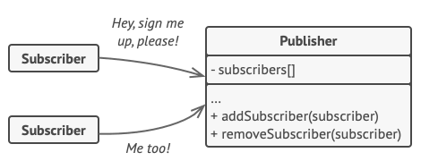

A subscription mechanism lets individual objects subscribe to event notifications.

Now, whenever an important event happens to the publisher, it goes over its subscribers and calls the specific notification method on their objects.

Real apps might have dozens of different subscriber classes that are interested in tracking events of the same publisher class. You wouldn’t want to couple the publisher to all of those classes. Besides, you might not even know about some of them beforehand if your publisher class is supposed to be used by other people.

That’s why it’s crucial that all subscribers implement the same interface and that the publisher communicates with them only via that interface. This interface should declare the notification method along with a set of parameters that the publisher can use to pass some contextual data along with the notification.

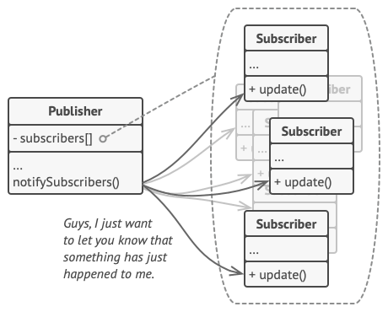

Publisher notifies subscribers by calling the specific notification method on their objects.

If your app has several different types of publishers and you want to make your subscribers compatible with all of them, you can go even further and make all publishers follow the same interface. This interface would only need to describe a few subscription methods. The interface would allow subscribers to observe publishers’ states without coupling to their concrete classes.

## Real-World Analogy

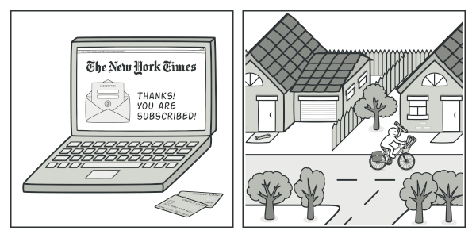

Magazine and newspaper subscriptions.

If you subscribe to a newspaper or magazine, you no longer need to go to the store to check if the next issue is available. Instead, the publisher sends new issues directly to your mailbox right after publication or even in advance.

The publisher maintains a list of subscribers and knows which magazines they’re interested in. Subscribers can leave the list at any time when they wish to stop the publisher sending new magazine issues to them.

# State

## Intent

**State** is a behavioral design pattern that lets an object alter its behavior when its internal state changes. It appears as if the object changed its class.

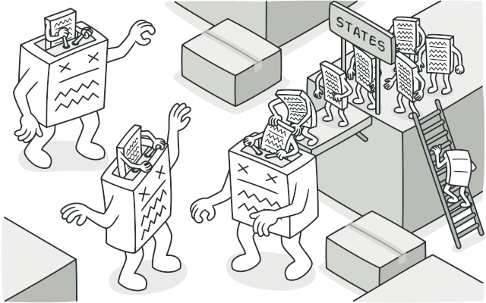

## Problem

The State pattern is closely related to the concept of a Finite-State Machine .

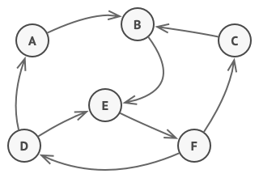

Finite-State Machine.

The main idea is that, at any given moment, there’s a finite number of states which a program can be in. Within any unique state, the program behaves differently, and the program can be switched from one state to another instantaneously. However, depending on a current state, the program may or may not switch to certain other states. These switching rules, called transitions, are also finite and predetermined.

You can also apply this approach to objects. Imagine that we have a Document class. A document can be in one of three states: Draft, Moderation and Published. The publish method of the document works a little bit differently in each state:

* In Draft, it moves the document to moderation.
* In Moderation, it makes the document public, but only if the current user is an administrator.
* In Published, it doesn’t do anything at all.

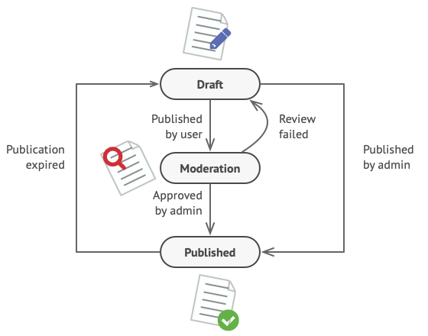

Possible states and transitions of a document object.

State machines are usually implemented with lots of conditional statements (if or switch) that select the appropriate behavior depending on the current state of the object. Usually, this “state” is just a set of values of the object’s fields. Even if you’ve never heard about finite-state machines before, you’ve probably implemented a state at least once. Does the following code structure ring a bell?

**class** **Document** **is**

**field** state: string

// ...

**method** publish() **is**

switch (state)

"draft":

state = "moderation"

break

"moderation":

**if** (currentUser.role == "admin")

state = "published"

break

"published":

// Do nothing.

break

// ...

The biggest weakness of a state machine based on conditionals reveals itself once we start adding more and more states and state-dependent behaviors to the Document class. Most methods will contain monstrous conditionals that pick the proper behavior of a method according to the current state. Code like this is very difficult to maintain because any change to the transition logic may require changing state conditionals in every method.

The problem tends to get bigger as a project evolves. It’s quite difficult to predict all possible states and transitions at the design stage. Hence, a lean state machine built with a limited set of conditionals can grow into a bloated mess over time.

## Solution

The State pattern suggests that you create new classes for all possible states of an object and extract all state-specific behaviors into these classes.

Instead of implementing all behaviors on its own, the original object, called context, stores a reference to one of the state objects that represents its current state, and delegates all the state-related work to that object.

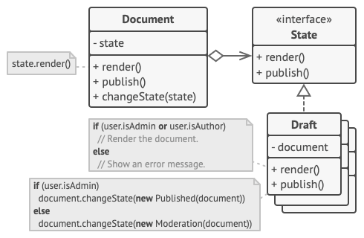

Document delegates the work to a state object.

To transition the context into another state, replace the active state object with another object that represents that new state. This is possible only if all state classes follow the same interface and the context itself works with these objects through that interface.

This structure may look similar to the [**Strategy**](https://refactoring.guru/design-patterns/strategy) pattern, but there’s one key difference. In the State pattern, the particular states may be aware of each other and initiate transitions from one state to another, whereas strategies almost never know about each other.

## Real-World Analogy

The buttons and switches in your smartphone behave differently depending on the current state of the device:

* When the phone is unlocked, pressing buttons leads to executing various functions.
* When the phone is locked, pressing any button leads to the unlock screen.
* When the phone’s charge is low, pressing any button shows the charging screen.

# SOLID Principle in Programming: Understand With Real Life Examples

In software development, **Object-Oriented Design** plays a crucial role when it comes to writing flexible, scalable, maintainable, and reusable code. There are so many benefits of using OOD but every developer should also have the knowledge of the SOLID principle for good object-oriented design in programming. The SOLID principle was introduced by ***Robert C. Martin***, also known as Uncle Bob and it is a coding standard in programming. This principle is an acronym of the five principles which is given below…

1. Single Responsibility Principle (SRP)
2. Open/Closed Principle
3. Liskov’s Substitution Principle (LSP)
4. Interface Segregation Principle (ISP)
5. Dependency Inversion Principle (DIP)

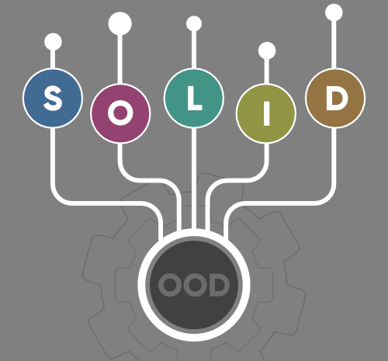

The SOLID principle helps in reducing tight coupling. Tight coupling means a group of classes are highly dependent on one another which you should avoid in your code. Opposite of tight coupling is loose coupling and your code is considered as a good code when it has loosely-coupled classes. Loosely coupled classes minimize changes in your code, helps in making code more reusable, maintainable, flexible and stable. Now let’s discuss one by one these principles…

**1. Single Responsibility Principle:**This principle states that “a class should have only one reason to change” which means every class should have a single responsibility or single job or single purpose. Take the example of developing software. The task is divided into different members doing different things as front-end designers do design, the tester does testing and backend developer takes care of backend development part then we can say that everyone has a single job or responsibility.  
Most of the time it happens that when programmers have to add features or new behavior they implement everything into the existing class which is completely wrong. It makes their code lengthy, complex and consumes time when later something needs to be modified. Use layers in your application and break God classes into smaller classes or modules.

**2. Open/Closed Principle:**This principle states that “software entities (classes, modules, functions, etc.) should be open for extension, but closed for modification” which means you should be able to extend a class behavior, without modifying it.  
Suppose developer A needs to release an update for a library or framework and developer B wants some modification or add some feature on that then developer B is allowed to extend the existing class created by developer A but developer B is not supposed to modify the class directly. Using this principle separates the existing code from the modified code so it provides better stability, maintainability and minimizes changes as in your code.

**3. Liskov’s Substitution Principle:**The principle was introduced by Barbara Liskov in 1987 and according to this principle “Derived or child classes must be substitutable for their base or parent classes“. This principle ensures that any class that is the child of a parent class should be usable in place of its parent without any unexpected behavior.  
You can understand it in a way that a farmer’s son should inherit farming skills from his father and should be able to replace his father if needed. If the son wants to become a farmer then he can replace his father but if he wants to become a cricketer then definitely the son can’t replace his father even though they both belong to the same family hierarchy.  
One of the classic examples of this principle is a rectangle having four sides. A rectangle’s height can be any value and width can be any value. A square is a rectangle with equal width and height. So we can say that we can extend the properties of the rectangle class into square class. In order to do that you need to swap the child (square) class with parent (rectangle) class to fit the definition of a square having four equal sides but a derived class does not affect the behavior of the parent class so if you will do that it will violate the Liskov Substitution Principle. Check the link [Liskov Substitution Principle](https://www.youtube.com/watch?v=Jecou7B3nhc" \t "_blank) for better understanding.

**4. Interface Segregation Principle:**This principle is the first principle that applies to Interfaces instead of classes in SOLID and it is similar to the single responsibility principle. It states that “do not force any client to implement an interface which is irrelevant to them“. Here your main goal is to focus on avoiding fat interface and give preference to many small client-specific interfaces. You should prefer many client interfaces rather than one general interface and each interface should have a specific responsibility.  
Suppose if you enter a restaurant and you are pure vegetarian. The waiter in that restaurant gave you the menu card which includes vegetarian items, non-vegetarian items, drinks, and sweets. In this case, as a customer, you should have a menu card which includes only vegetarian items, not everything which you don’t eat in your food. Here the menu should be different for different types of customers. The common or general menu card for everyone can be divided into multiple cards instead of just one. Using this principle helps in reducing the side effects and frequency of required changes.

**5. Dependency Inversion Principle:**Before we discuss this topic keep in mind that Dependency Inversion and [Dependency Injection](https://en.wikipedia.org/wiki/Dependency_injection) both are different concepts. Most of the people get confused about it and consider both are the same. Now two key points are here to keep in mind about this principle

* High-level modules/classes should not depend on low-level modules/classes. Both should depend upon abstractions.
* Abstractions should not depend upon details. Details should depend upon abstractions.

The above lines simply state that if a high module or class will be dependent more on low-level modules or class then your code would have tight coupling and if you will try to make a change in one class it can break another class which is risky at the production level. So always try to make classes loosely coupled as much as you can and you can achieve this through abstraction. The main motive of this principle is decoupling the dependencies so if class A changes the class B doesn’t need to care or know about the changes.  
You can consider the real-life example of a TV remote battery. Your remote needs a battery but it’s not dependent on the battery brand. You can use any XYZ brand that you want and it will work. So we can say that the TV remote is loosely coupled with the brand name. Dependency Inversion makes your code more reusable.

## Measure and manage Technical Debt

# Technical Debt

## What is Technical Debt?

Technical debt (also known as tech debt or code debt) describes what results when development teams take actions to expedite the delivery of a piece of functionality or a project which later needs to be refactored. In other words, it’s the result of prioritizing speedy delivery over perfect code.

Cunningham described how he initially came up with the [technical debt metaphor](http://wiki.c2.com/?WardExplainsDebtMetaphor):

“With borrowed money, you can do something sooner than you might otherwise, but then until you pay back that money you’ll be paying interest. I thought borrowing money was a good idea, I thought that rushing software out the door to get some experience with it was a good idea, but that of course, you would eventually go back and as you learned things about that software you would repay that loan by refactoring the program to reflect your experience as you acquired it.”

According to the resulting paper, which was published by the Software Engineering Institute as “Towards an Ontology of Terms on Technical Debt,” there are 13 distinct types of technical debt and a set of key indicators for each.

* Architecture Debt
* Build Debt
* Code Debt
* Defect Debt
* Design Debt
* Documentation Debt
* Infrastructure Debt
* People Debt
* Process Debt
* Requirement Debt
* Service Debt
* Test Automation Debt
* Test Debt

## ****Metrics for Measuring Your Technical Debt****

### ****New Bugs vs. Closed Bugs****

Here’s a nice easy one to start.

Every known bug is essentially a tiny sliver of technical debt. If you want to know your total debt, it’s important for your engineers to keep a tally.

Assuming your engineers make a note of when bugs are fixed, you can calculate how effectively you are managing your technical debt. **If new bugs are outnumbering closed bugs, you need to make some changes.**

### ****Code Quality****

Complex code is a sure sign of growing technical debt. At some point, someone is going to have to unravel that mess. **Code quality** is an aggregation of several metrics that **quantify the overall quality and complexity** of your code:

* Cyclomatic complexity
* Class coupling
* Lines of code
* Depth of inheritance

With each of these individual metrics, you’re aiming for the lowest possible score. The same goes for the overall metric of code quality.

### ****Cycle Time****

Another metric that is closely linked to code quality is **cycle time**.

In technical terms, this measures the amount of time that passes between the first commit, and deployment. But when you’re measuring technical debt, you need to study the time it takes to make changes to existing code and to solve problems without using quick fixes.

If your engineers are spending hours fixing small bugs, you know that there is some technical debt lurking in your code.

### ****Code Churn****

**Code churn** is a metric that counts the number of times a particular line has seen code deleted and replaced, or rewritten.

When you are developing a new feature or working on a particular section of your product, some churn is inevitable. But after you have launched a new version and fixed the standout bugs, code churn should start to diminish quite rapidly.

If you see high churn in any area of your code over a longer period of time, it probably means that mistakes or quick fixes are being made with each iteration.

### ****Code Coverage****

In a sense, the **code coverage** metric looks at the same issue from the opposite direction.

In this case, you are measuring how much of your code is executed when you run your testing suite. This gives you an indication of how efficiently your code has been written — the more lines that are unused, the more likely it is that you have poorly written code.

**A good target number here is 80%**. Higher than this is to be commended, while a lower score indicates work to be done.

### ****Code Ownership****

In the culinary world, it’s often said that “too many cooks spoil the broth”.

The same idea can be applied to software engineering. If you get too many people working on the same tasks, you can easily end up with a steaming pile of cruft. That said, you don’t want only one engineer taking ownership of an entire project. If they get sick or leave your organization, it’s game over.

For this reason, it’s a good idea to analyze who has worked on which projects. As part of the process, you should count how many engineers have contributed to each project — this is your **code coverage**.

The average figure will reveal whether you have an efficient system for delegating tasks, or a free-for-all. The ideal situation is to have one complete team taking charge of each project.

### ****Technical Debt Ratio (TDR)****

As the name implies, this metric was designed specifically for calculating the overall future cost of technical debt. This can be in terms of time, or some other resource.

The equation is relatively simple:

(Remediation Cost ÷ Development Cost) × 100 = TDR

In this case, **remediation cost** can be calculated as a function of the code quality metrics mentioned above.

**Development cost** is a simple calculation of the number of lines of code required to build a product or feature, divided by the average resources expended per line. Put the two together in your TDR equation, and you end up with a simple ratio that tells you how much time or how many resources you will need to spend on fixing problems. **In an ideal world, your TDR would be around 5%**. If you get to multiples of this figure, it’s long past time to start tackling your technical debt!